**Character and Set Design Couse Work 1 Report**

**Introduction**

In this report I will be detail my entire design and modelling process for the robotic athlete. This will include the design pipeline, working and adapting from inspiration, the modelling techniques used, and justification to sing a wide variety of techniques that Maya has to offer.

**Pre-Production and Planning**

To begin with I created a style sheet and mood board in order to get inspiration and ideas about what I could use for my robot model (seen in appendix). I used pictures of robots from films such as *Real Steel*, *iRobot,* and *Star Wars*, along with some examples of real-life robots from companies such as Boston Dynamics. Along with these, I also added pictures of human Olympians in order to get ideas for both the types of movements the Robotic Olympoid should be able to perform, as well as ideas for real-world objects that could be modelled alongside the main robot as either props/items or as part of the Olympoid itself.

Initially I thought of a one-armed Robot with wheels as its way of movement. The idea behind the single arm was that the arm could be revolved at speed to enable good throwing performance by using centrifugal forces to its advantage. Utilising wheels would differentiate the robot from looking like a total human copy, something I didn’t want, as well as giving it good performance in track events.  
These factors changed however into a more traditional, human styled design with two arms and two legs. This was mainly for the fact that I preferred the look of two arms from my development sketches, plus the robot would be able to (theoretically) be able to perform well in a wider variety of sports with two arms (archery for example would be much harder with just one arm).  
I chose to replace the wheels with Para-Olympian prosthetic blades, as again I felt that these would provide more versatility in the sports that the Olympoid could compete in. Additionally, I felt that the blades fitted the design of my Olympoid much better than one with wheels.

After having done some development drawings, and playing with different ideas for the Olympoid, I settled on the features I wanted and began my final sketches and blueprints for the Robot. Blueprints from multiple angles allowed me to import these into Maya and model accurately from them. I chose to sketch out each body parts separately so that I could more accurately draw the different viewpoints needed to model from.

From the beginning I wanted my robot to have some sort of curved shape to it, to give a more interesting look. This was also coupled with the fact that in events such as running or swimming, aerodynamics will play a big part into how well the competitor can perform. Therefore, having an aerodynamic bevel on the front of the Olympoid’s body will be able to cut through the air or water to reduce resistance, akin to that of a human nose.

The style of the arms came from various images found in the style sheet. The shoulder and upper arm was inspired from the T-800 Terminator, having a exoskeleton of sorts and exposed wiring and hydraulics. The lower arm was based off a Real Steel fighting robot, and Sonny from iRobot, as well as the claw from the Boston Dynamic’s robot pictured in the appendix.

Inspiration for the leg can be seen from the artificial muscles that Sonny has in iRobot, as I liked the idea of mimicking a human’s mechanics in a robot. The lower leg uses a Para-Olympian’s prosthetic blade as mentioned above due to its versatility in many events, whilst also having a unique look to it compared to a traditional lower leg shape.

Finally, the head was inspired by BB-8 from Star Wars. The ability to look in 360 degrees, coupled with the non-human styled head appealed to me. I also felt that making the head irregular compared to a human head would add individuality to the design.

The decision to not draw top viewpoints for the arm and legs was made since the geometry for these would be very simple from this angle because of the spherical geometry of the shoulder pads and hip connector. Therefore, inferring how these parts should look would be easily achievable whilst modelling in Maya.

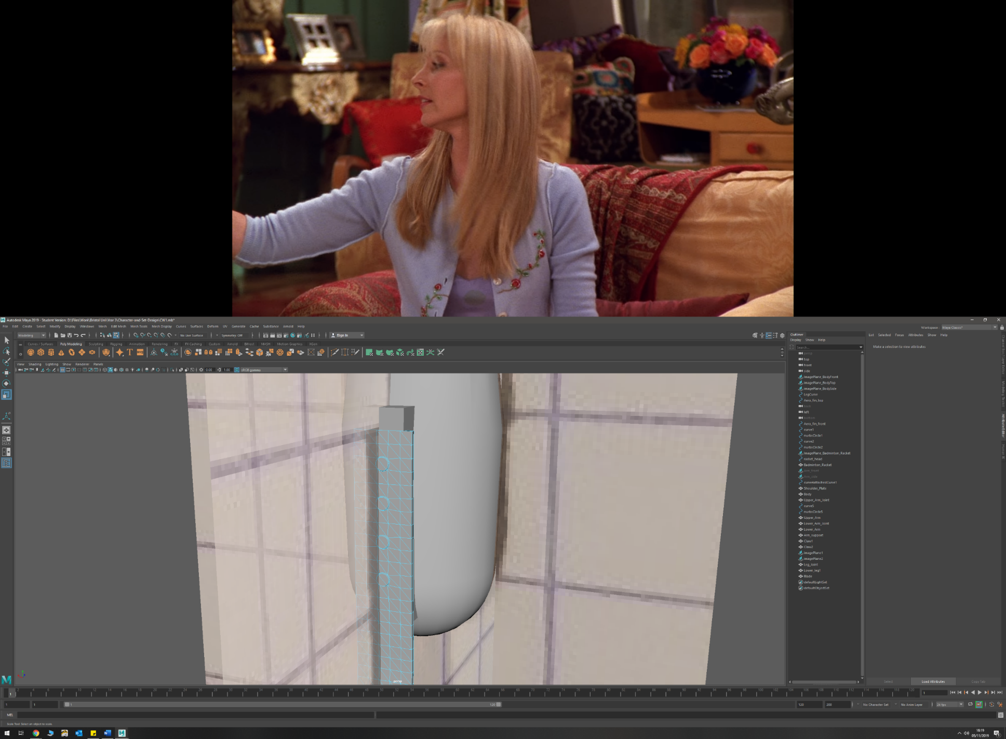**Techniques and Surfaces**

* Circularize
  + Camera on head
  + Screws on blade mount
  + Shoulder joint
* Primitive up modelling
  + Body
  + Leg (upper and lower)
  + Forearm
  + Badminton racket handle

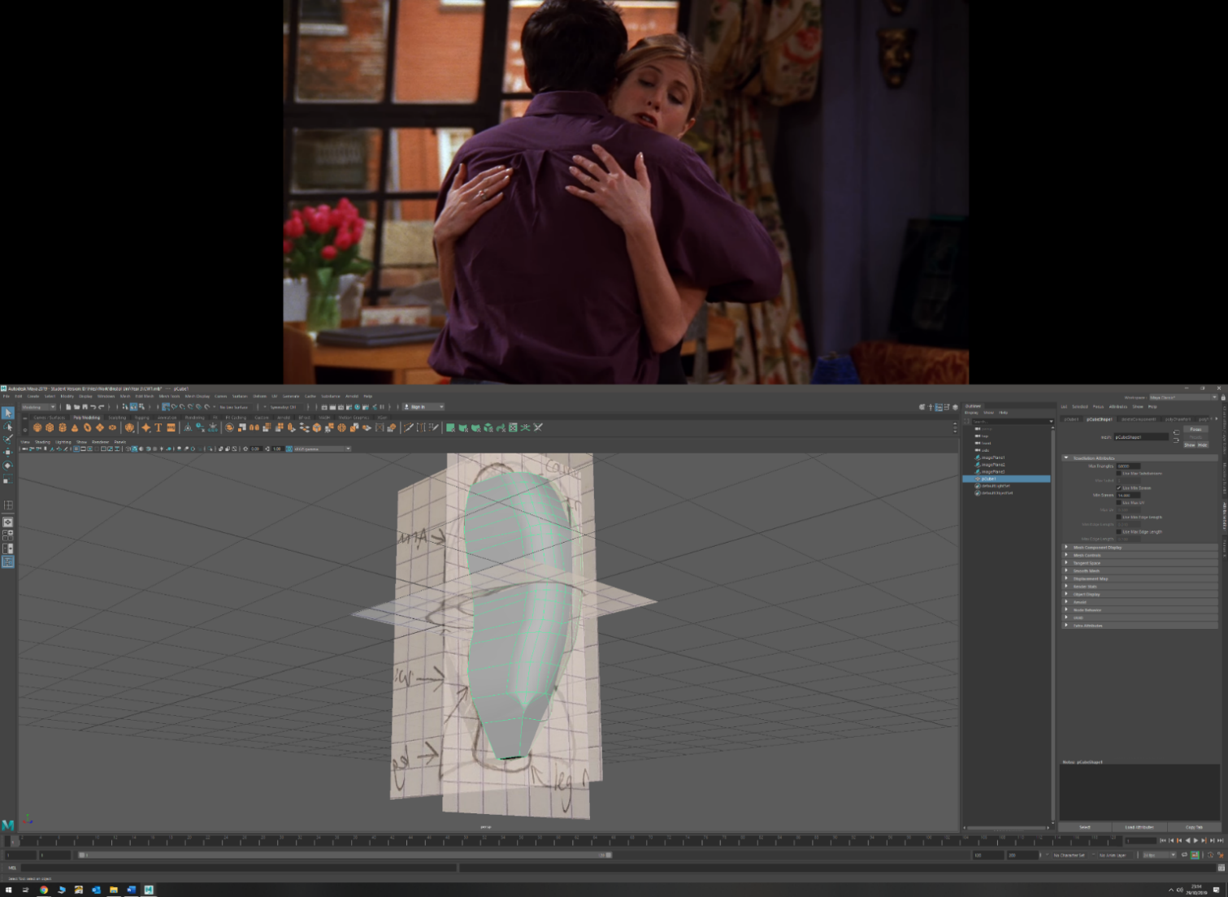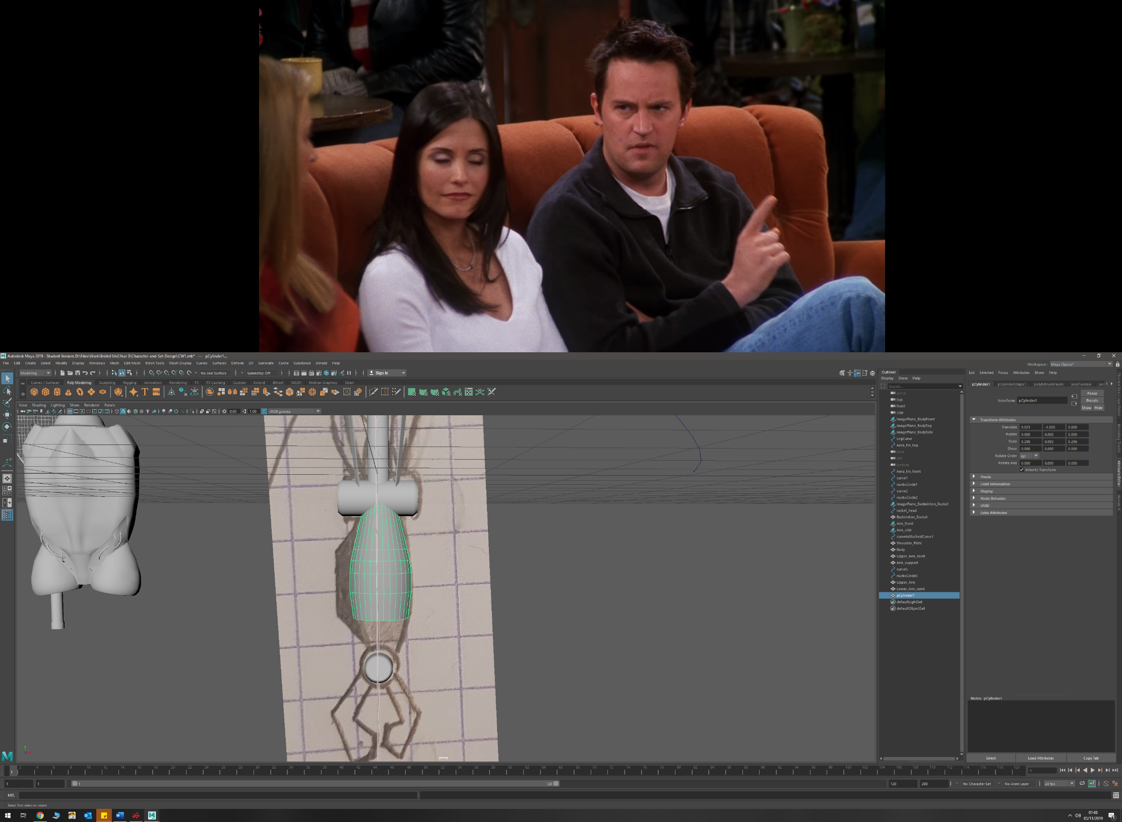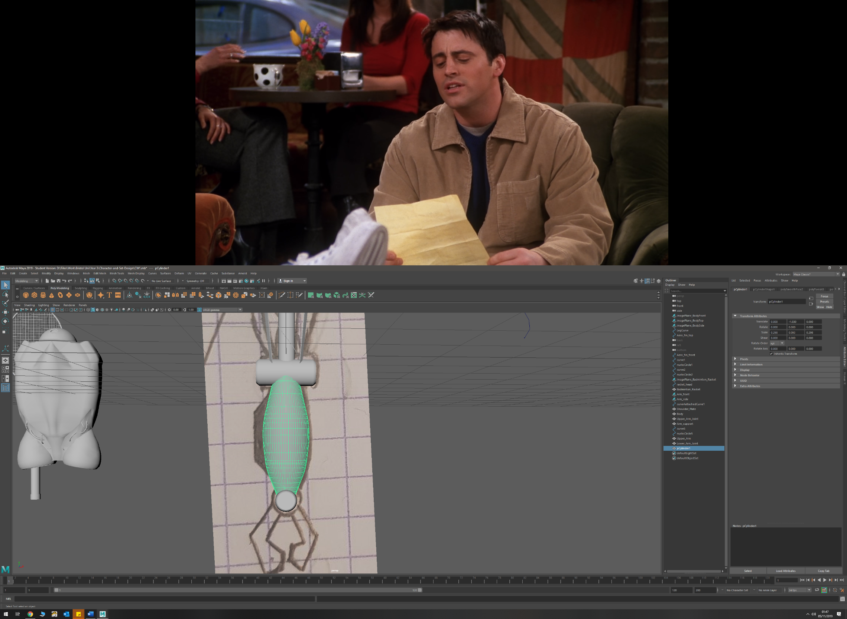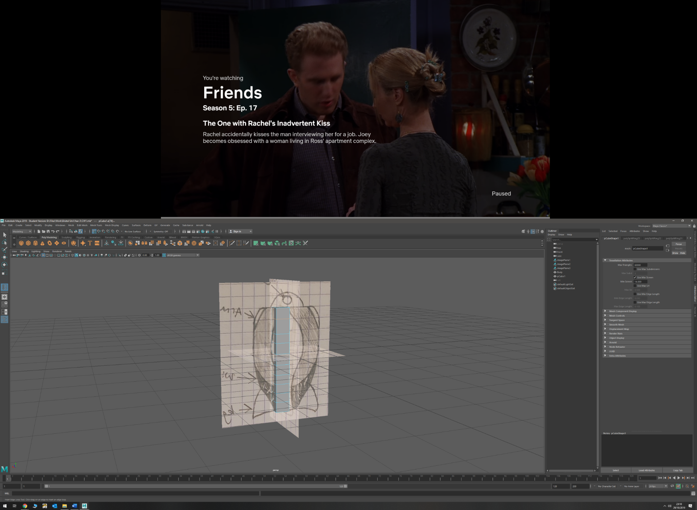

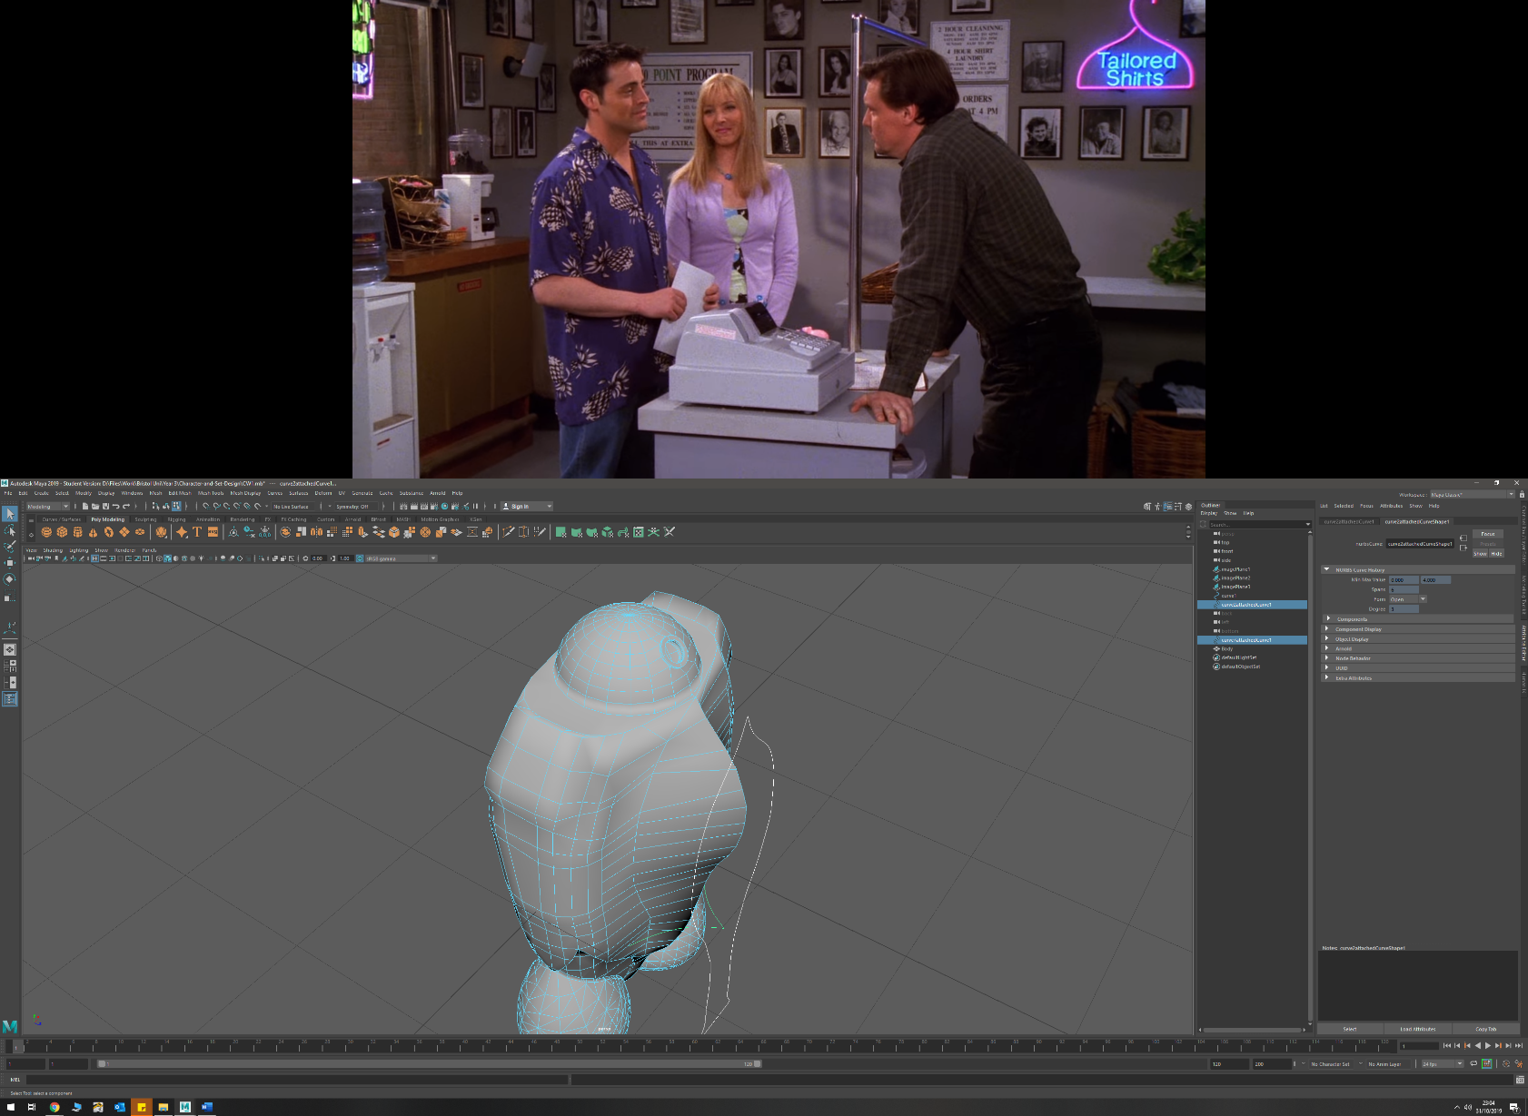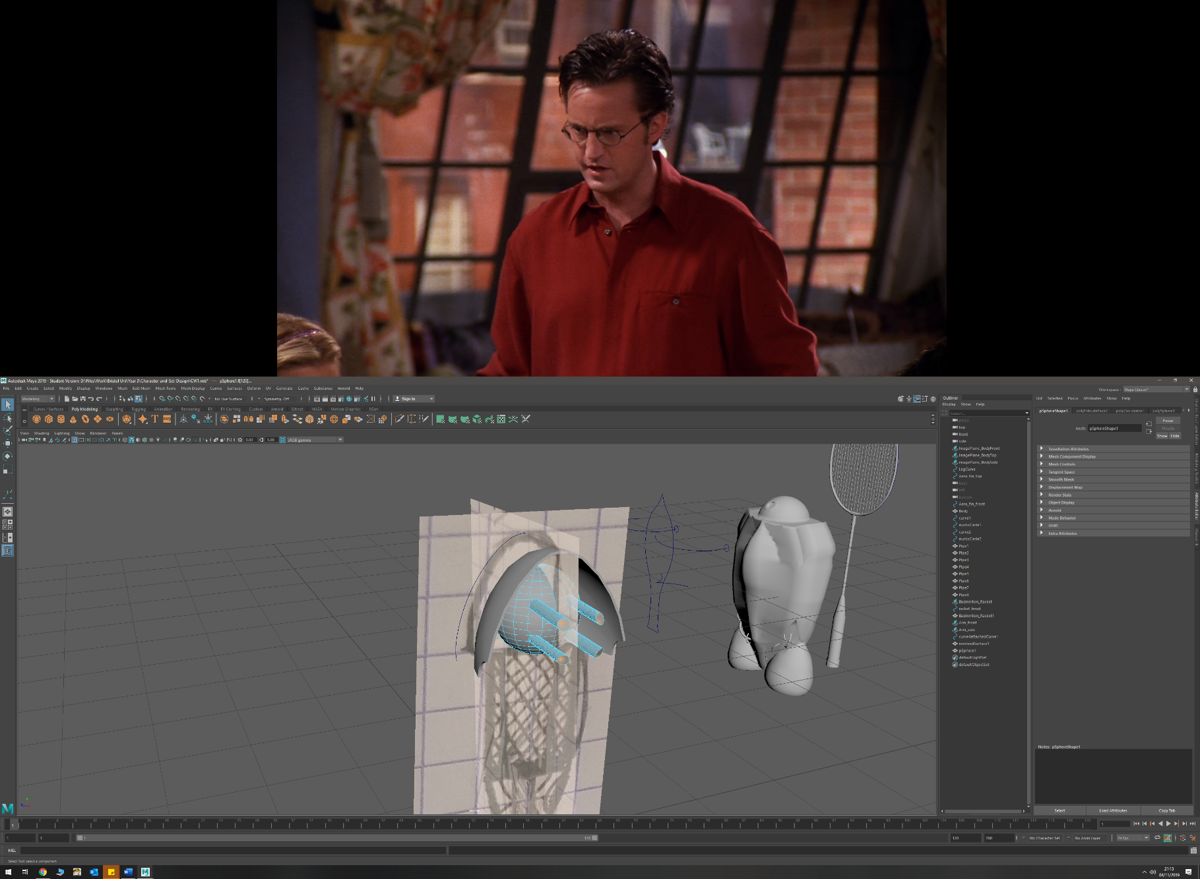

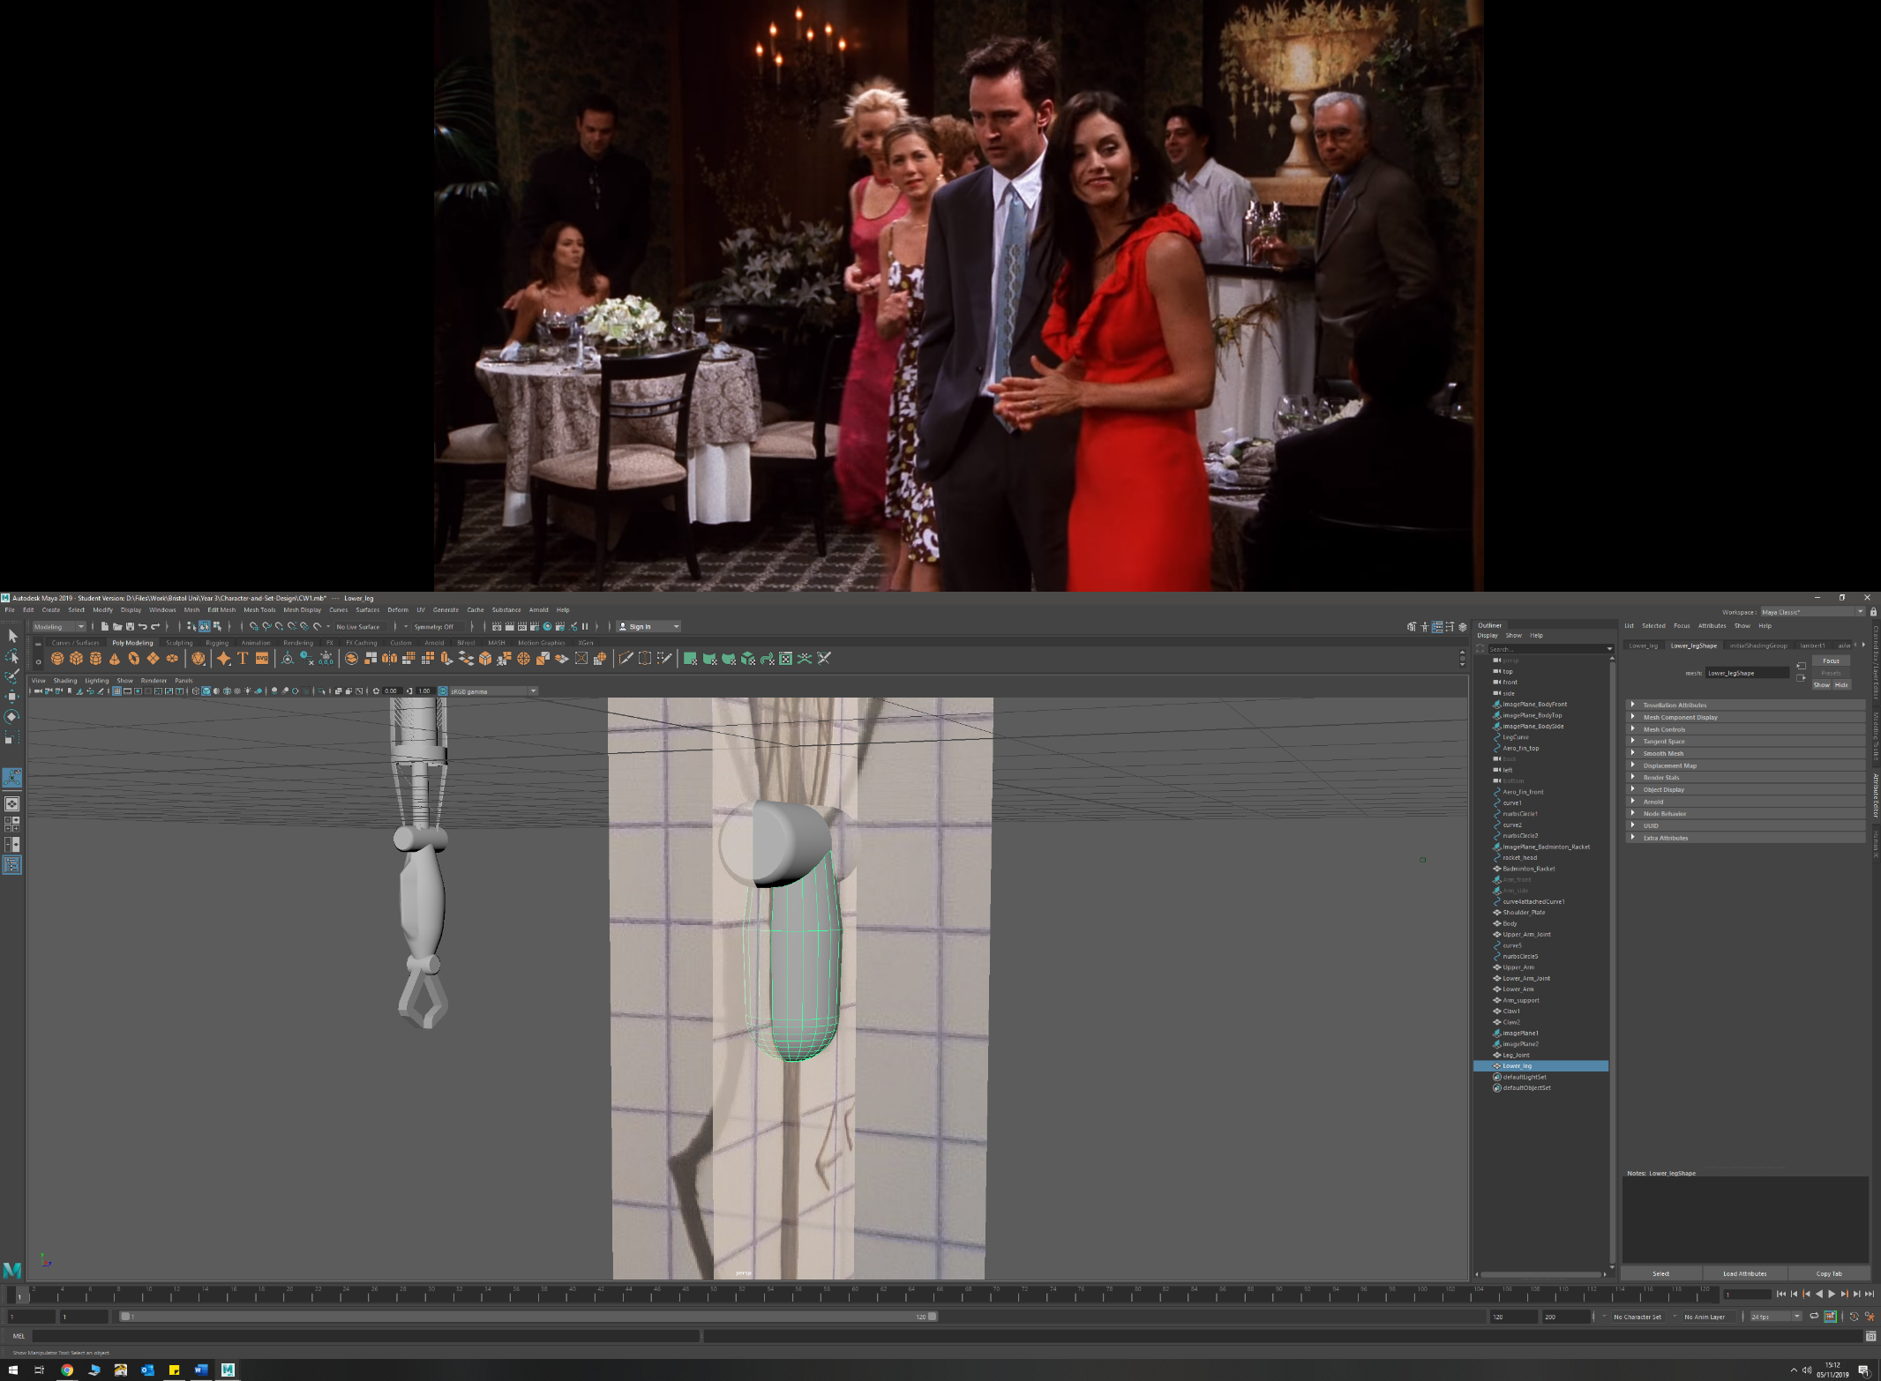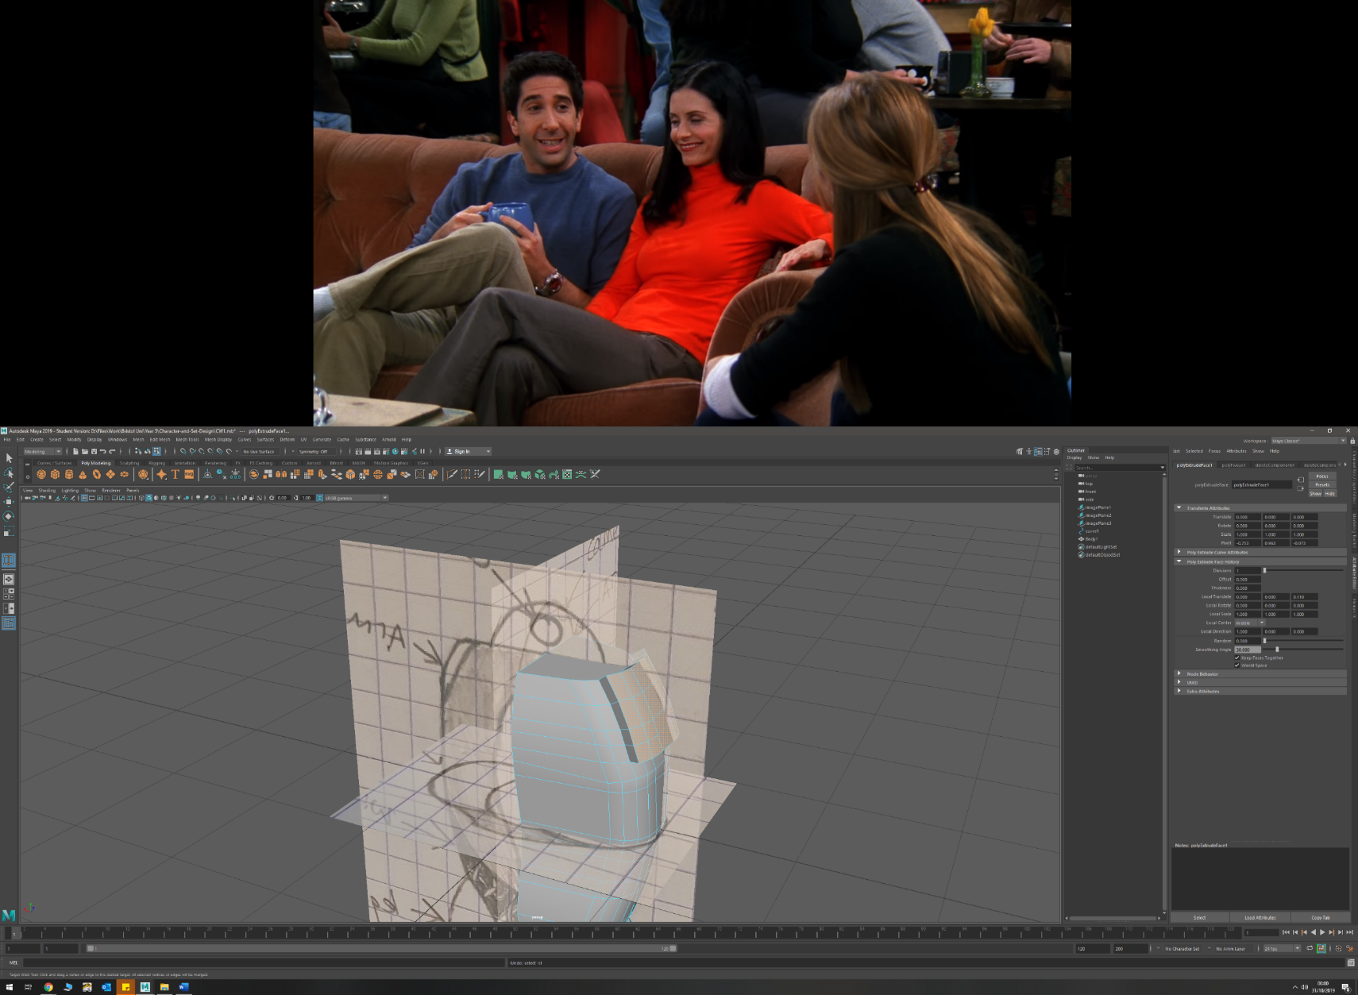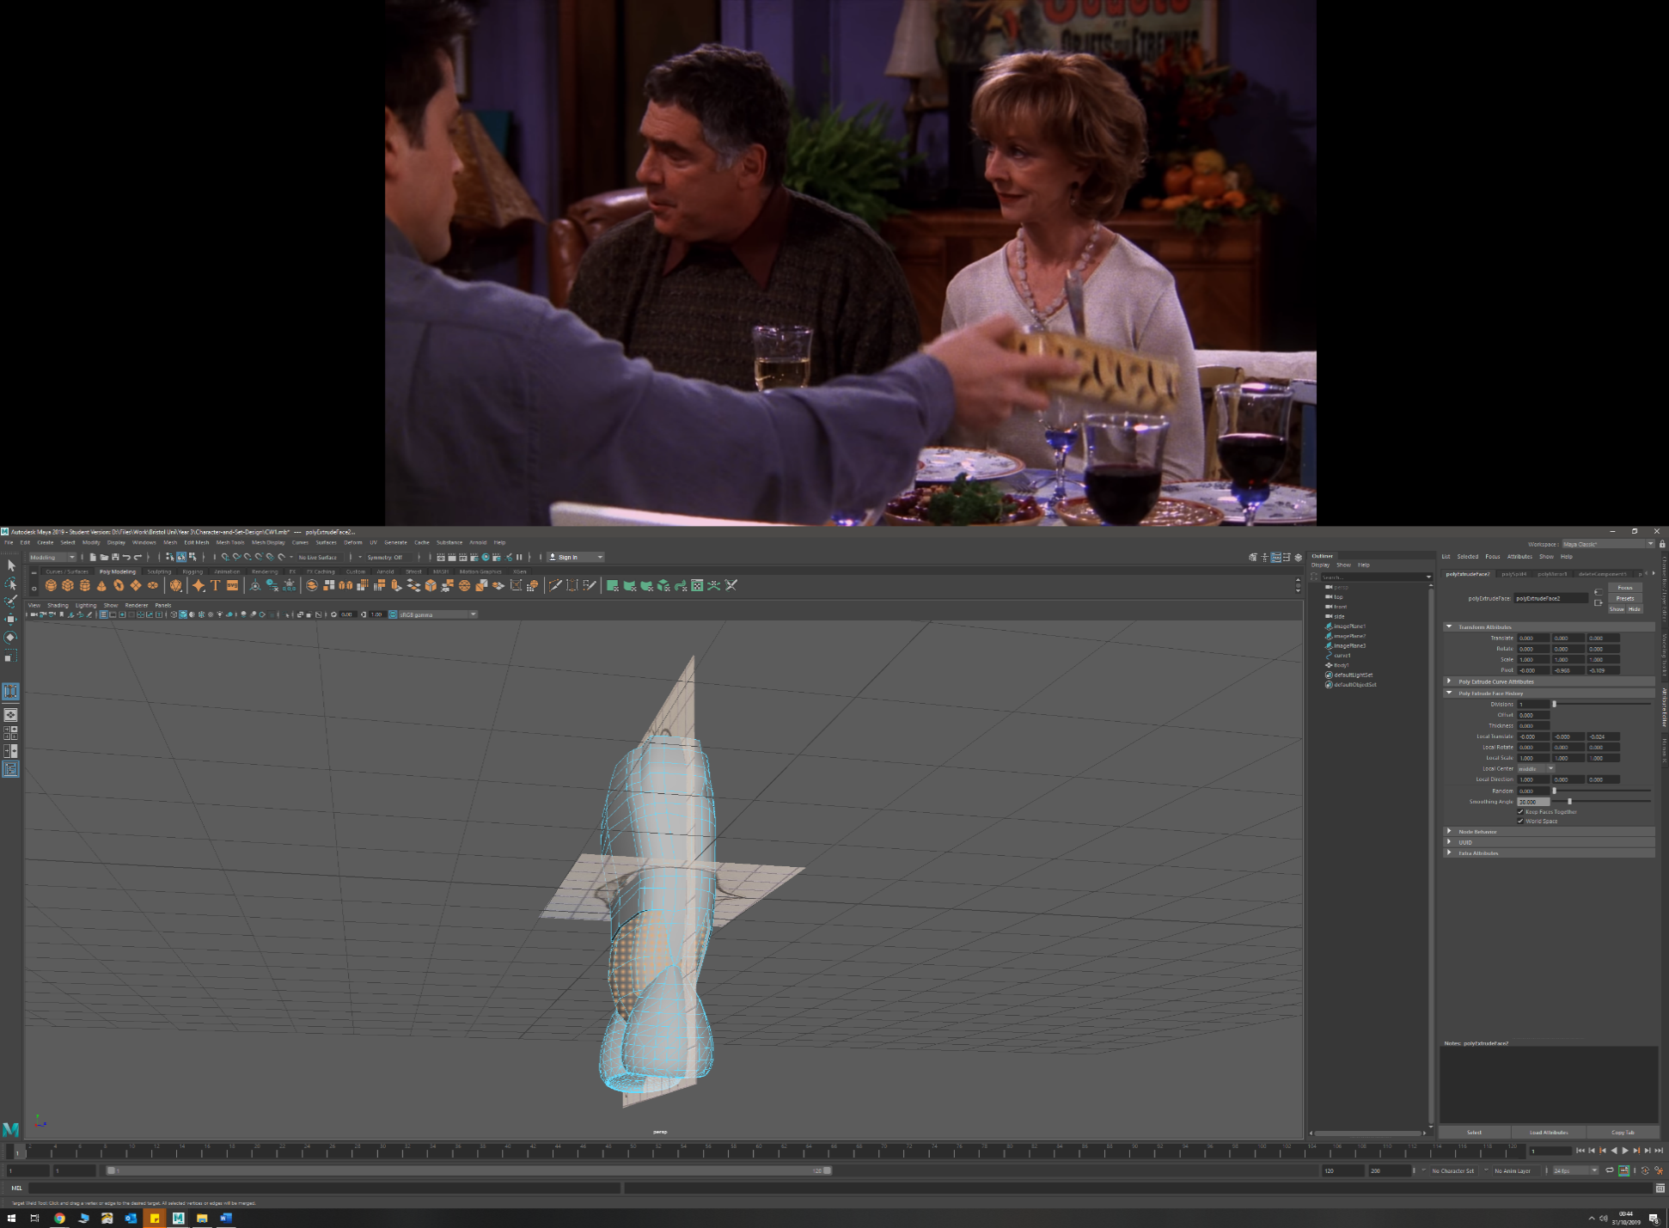

* Extruding faces (outward and inwards)
  + Shoulder mount (outwards) from torso
  + Lower torso detail (inwards) to create depth
  + Forearm (outwards)
  + Leg (upper and lower) (outwards)
  + Arm exoskeleton (outwards) to create thickness and the connecting arms to ring
  + Running blade (outwards) to create thickness
  + Head mount (inwards) to create the mount from original head
  + Badminton racket (faces outwards) to create handle and stem

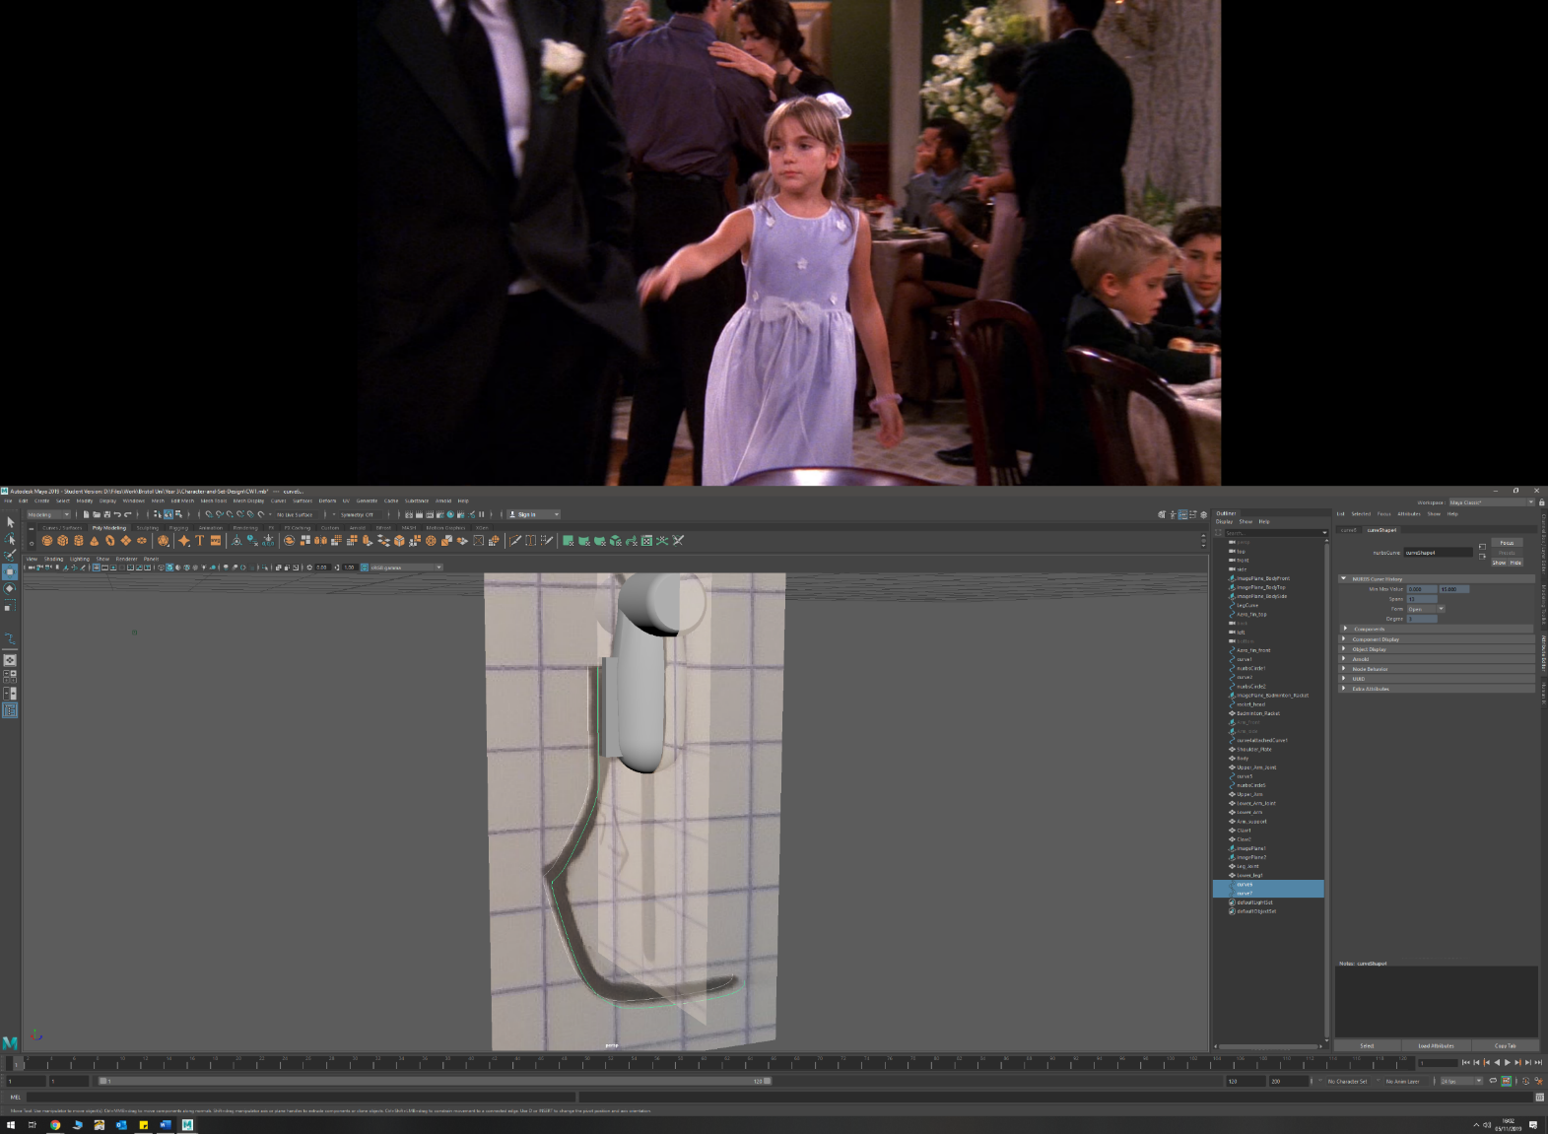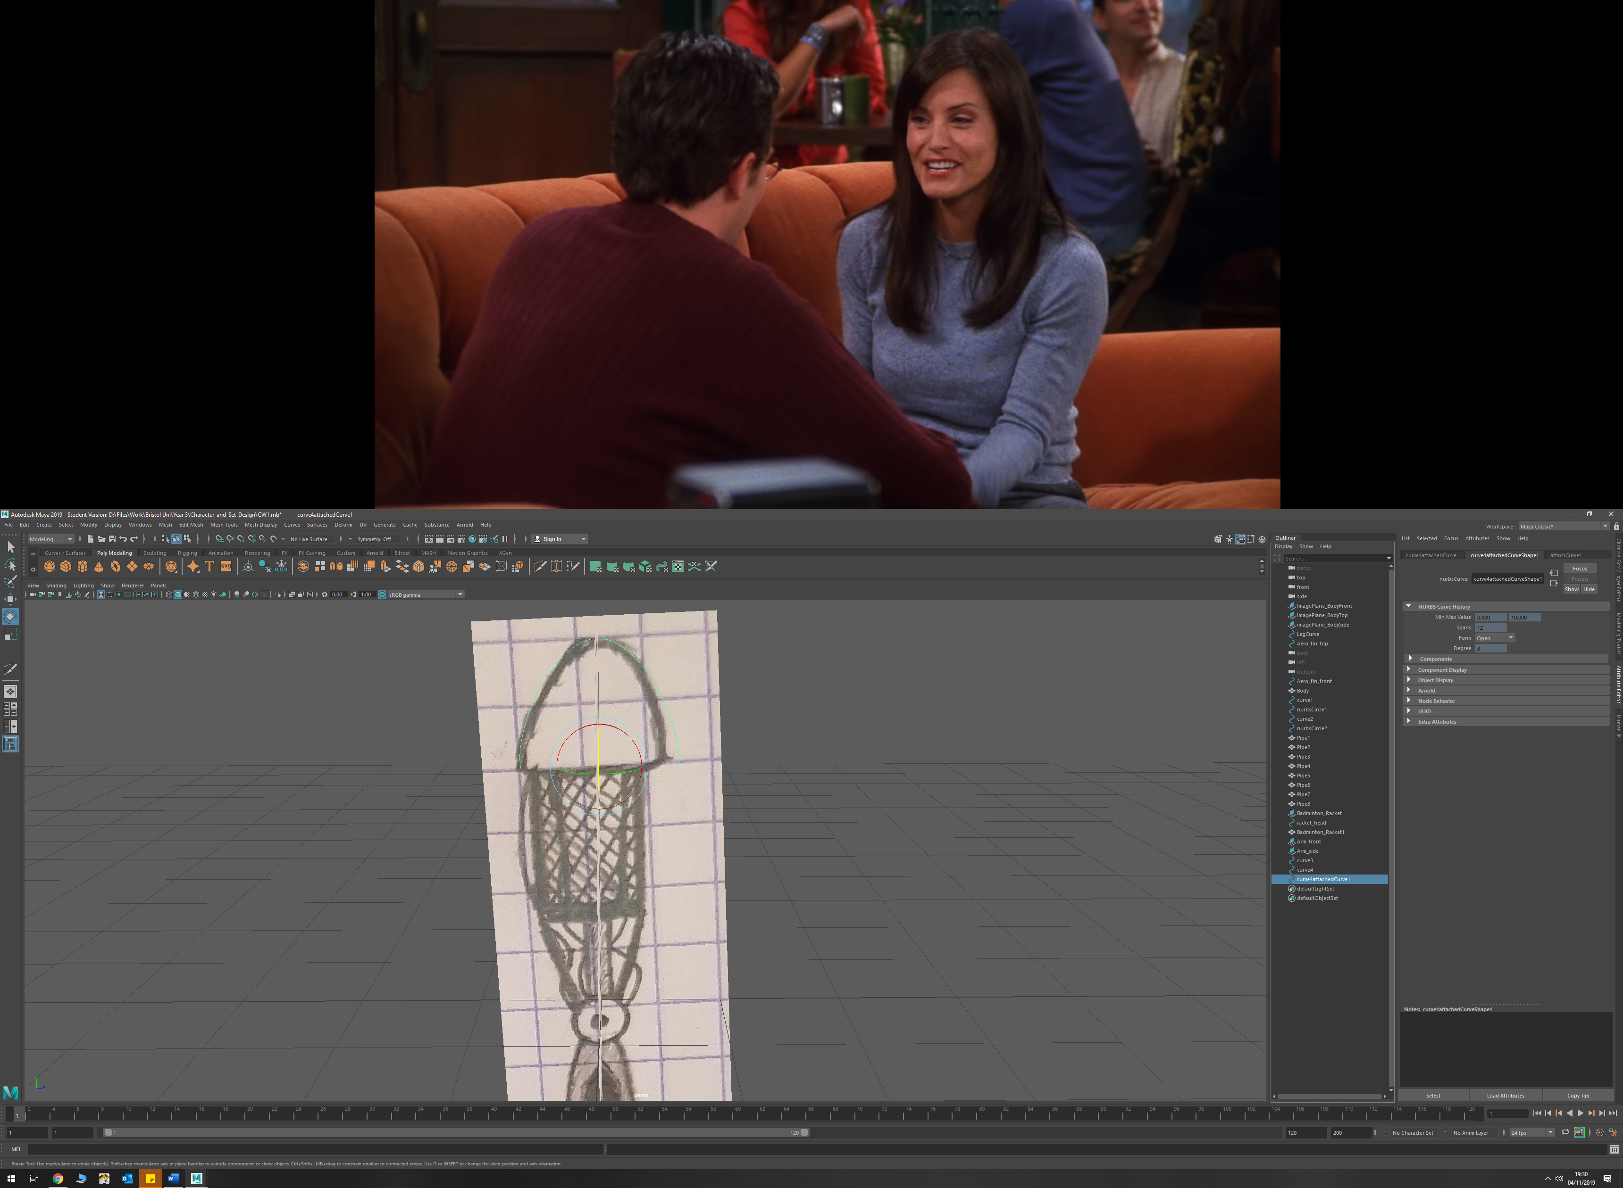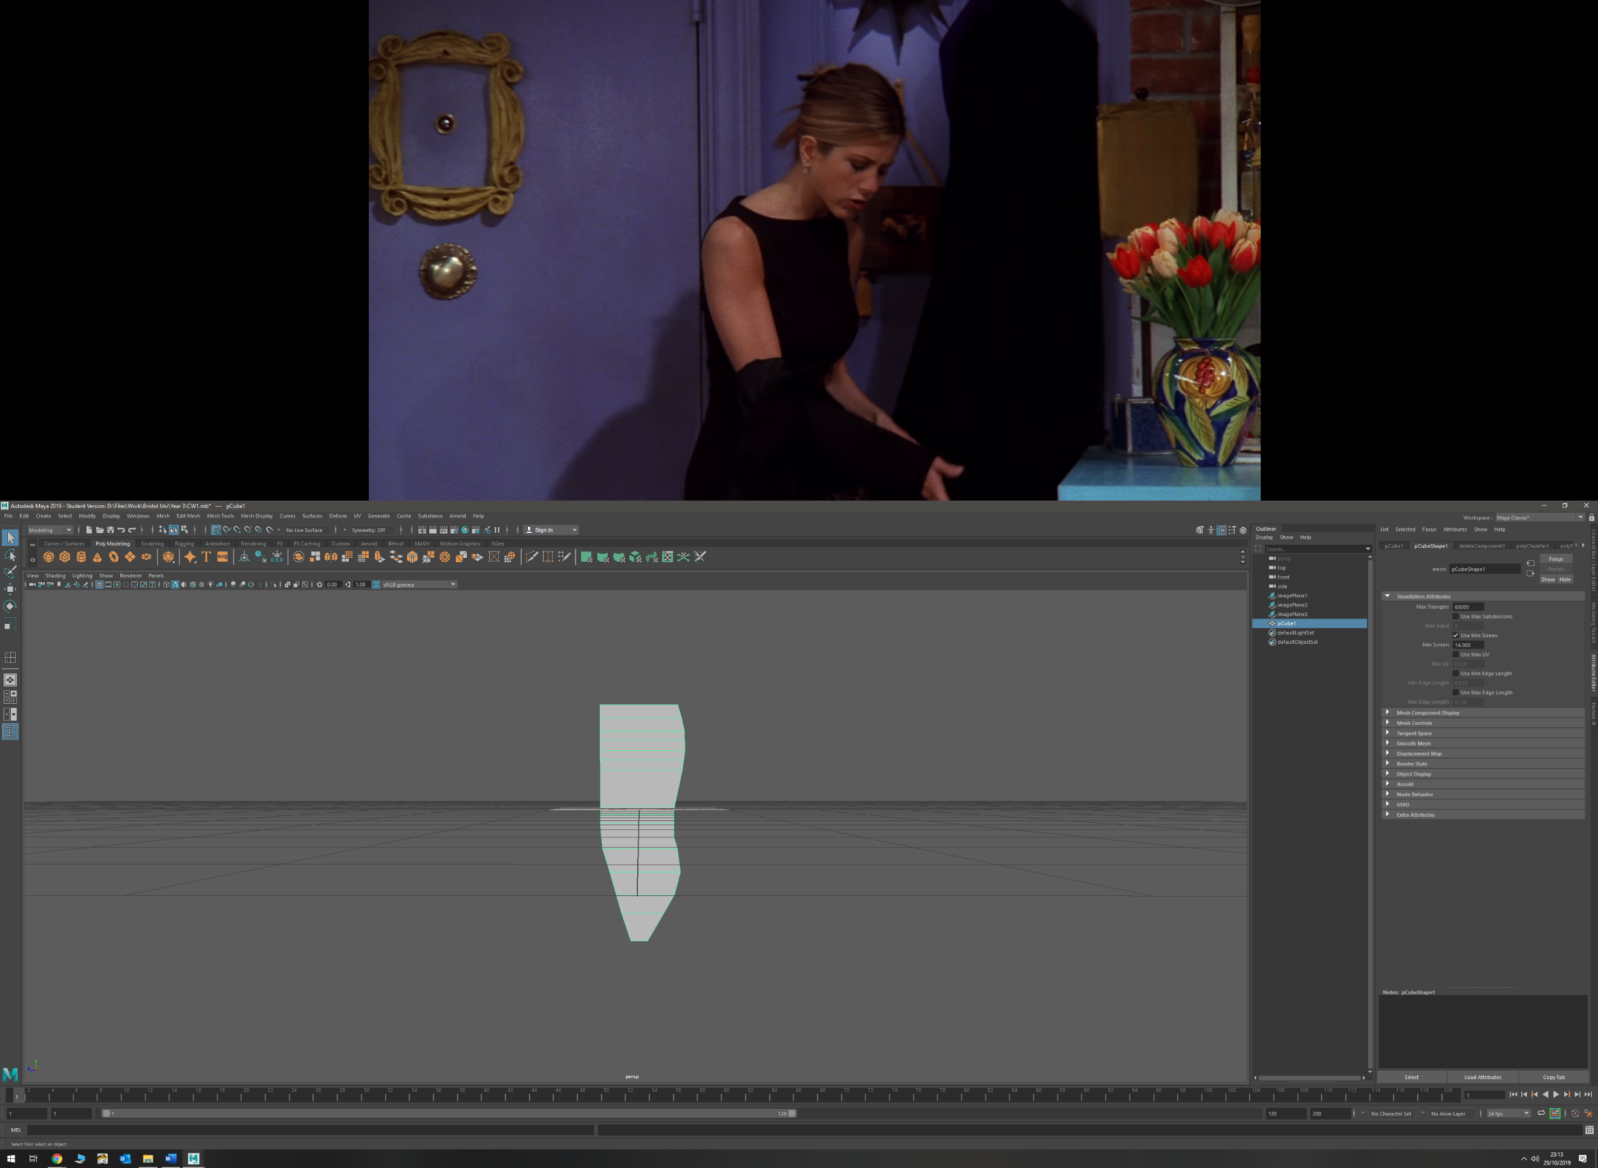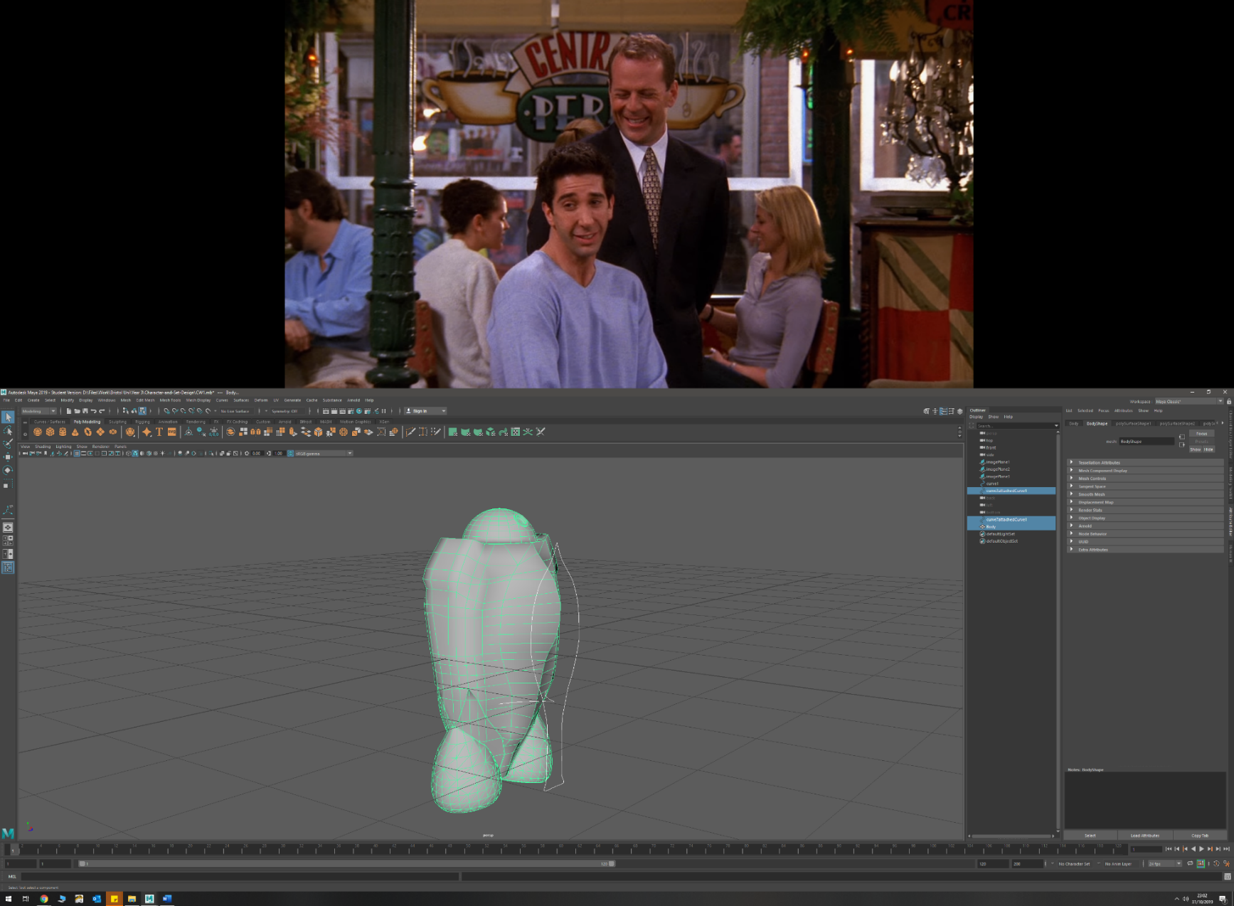v

* EP curves
  + Areo-fin
  + Running Blades
  + Shoulder pad
* Scaling faces and edges (outwards and inwards)
  + Arm (edges and faces outwards) to create forearm fin and taper forearm inwards
  + Leg (upper and lower) (edges inwards, faces outwards) to taper inwards at ends and add detail
  + Badminton racket handle (faces outwards) to widen stem for handle
  + Head mount (inwards)
* Sub-dividing
  + Torso
  + Torso Areo-fin

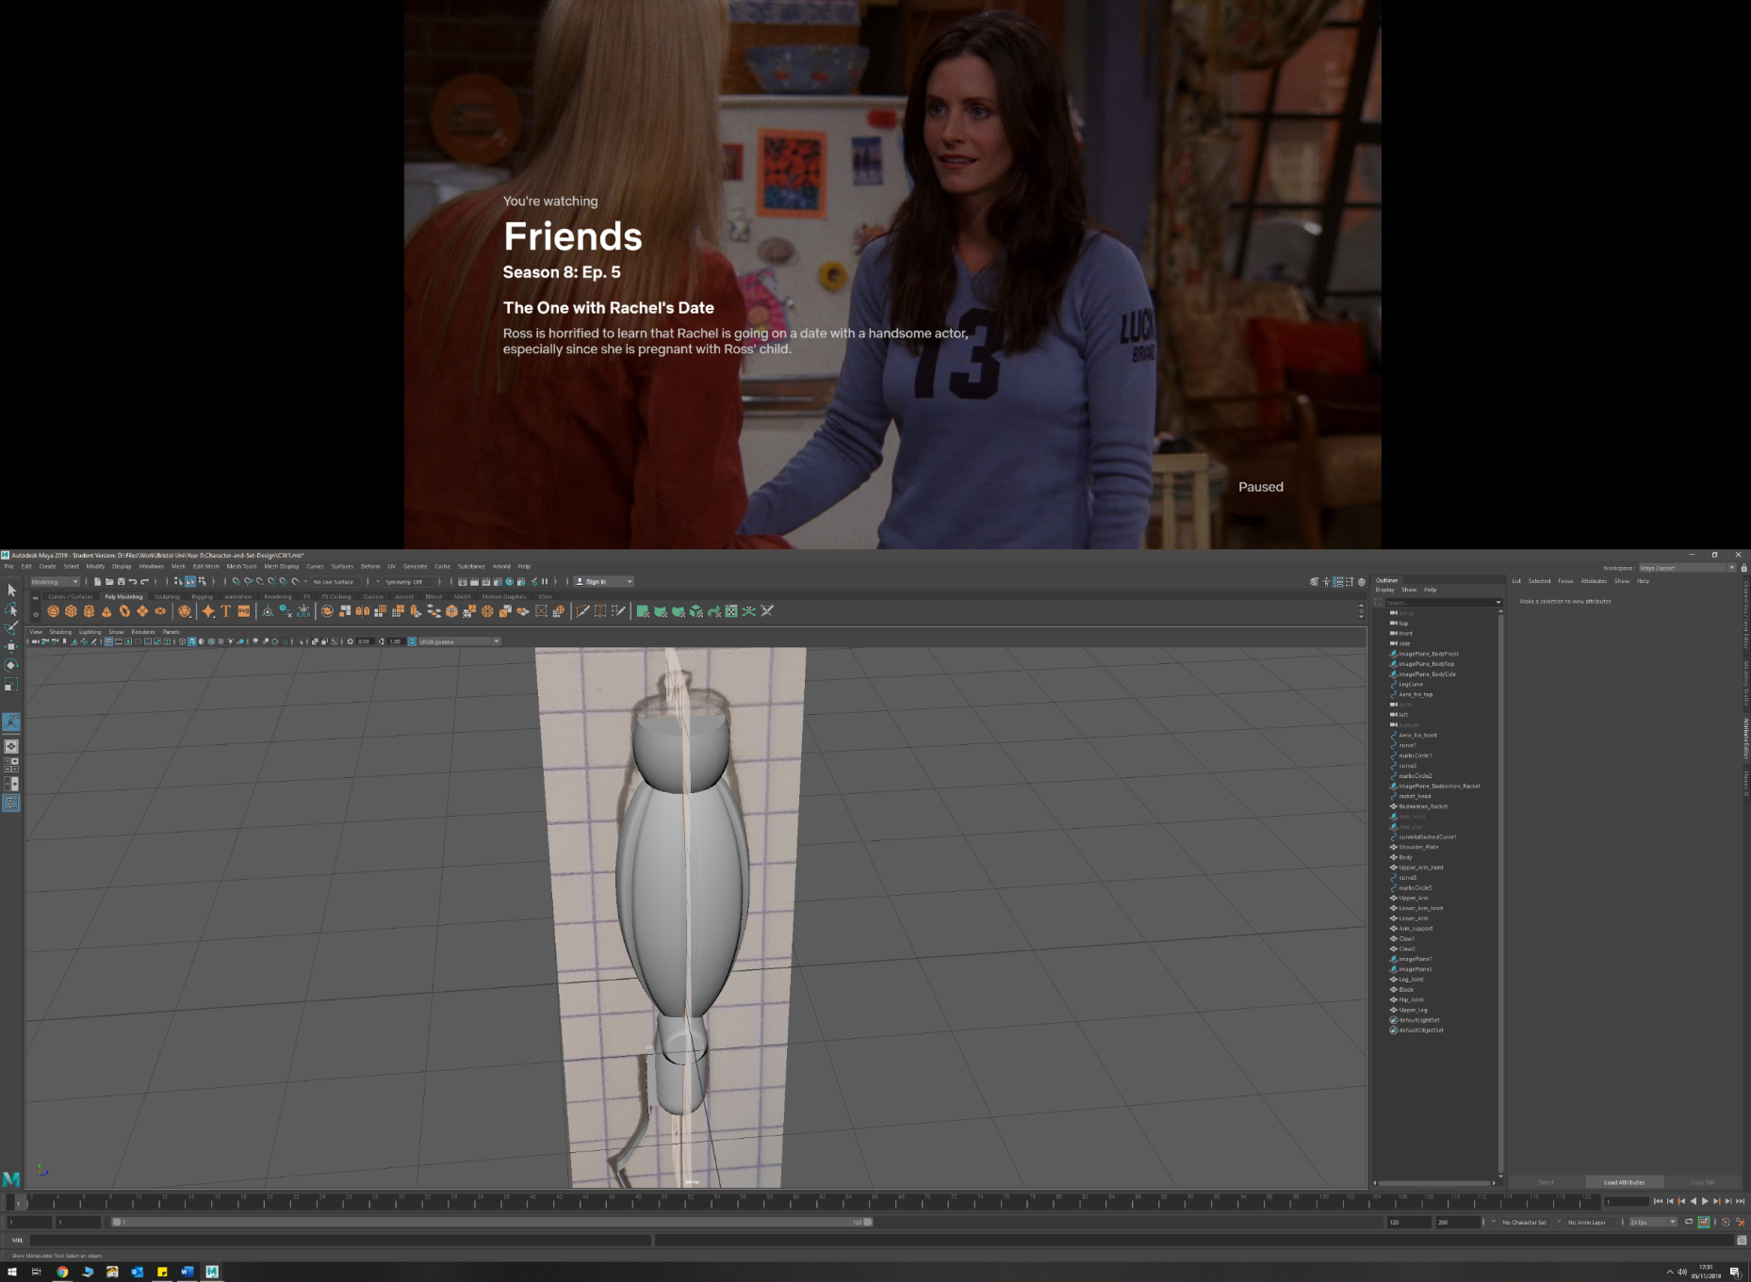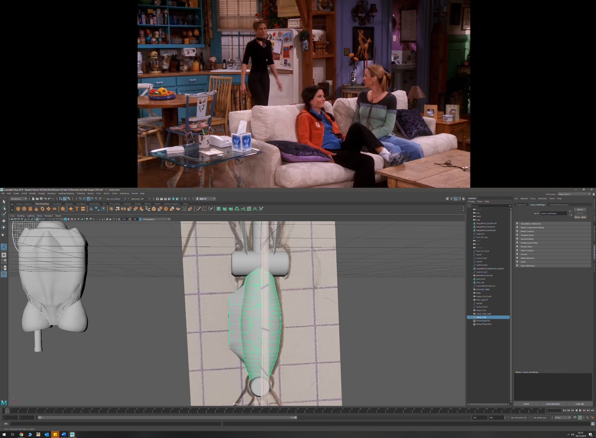

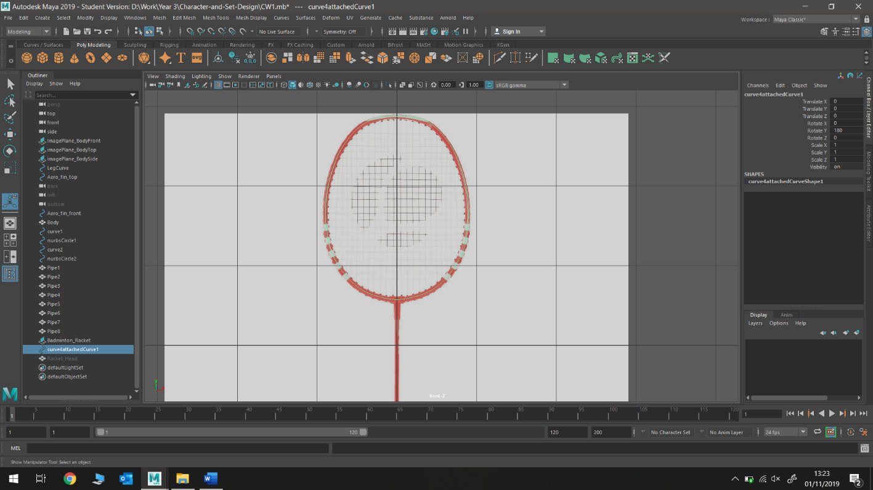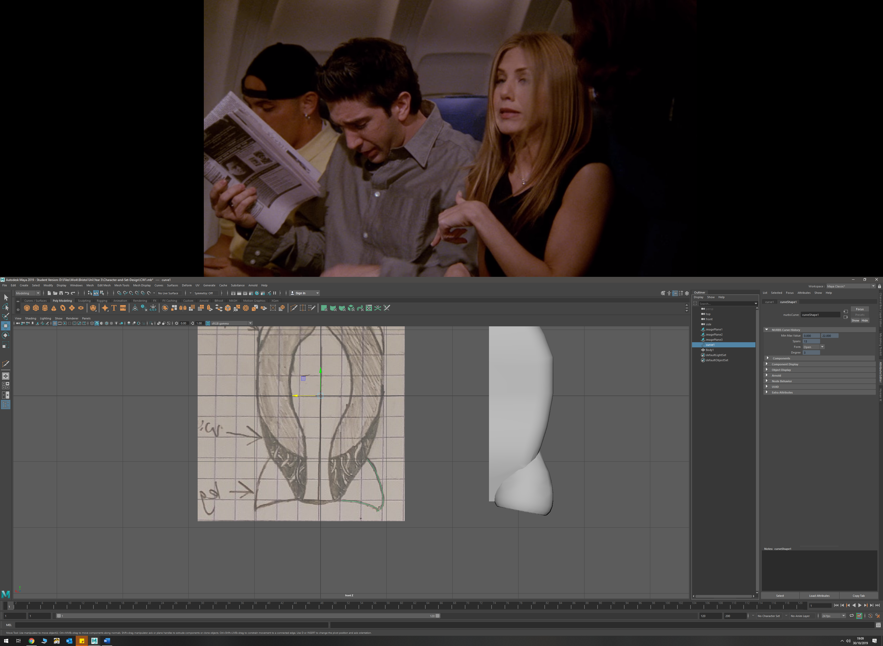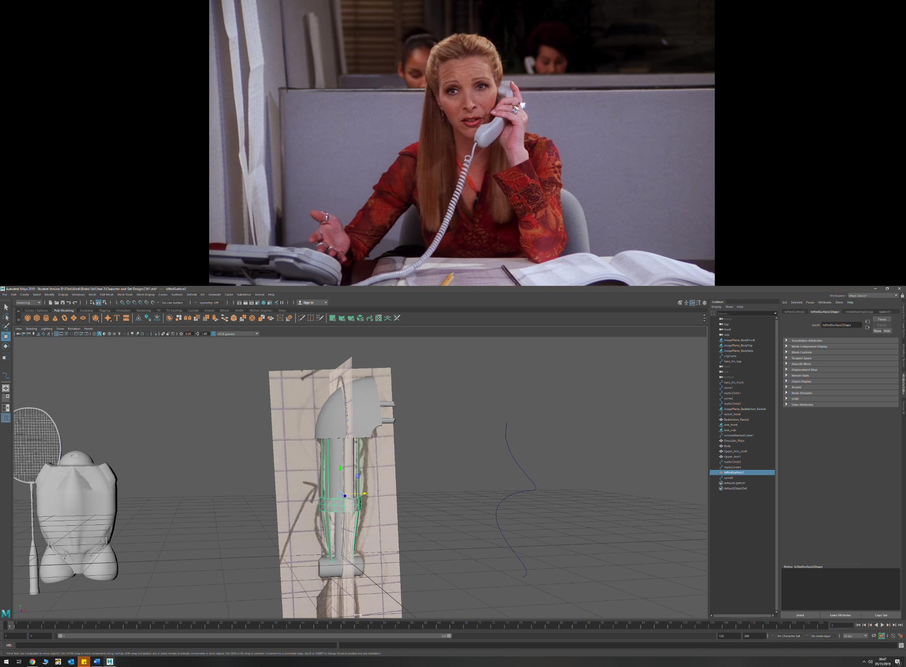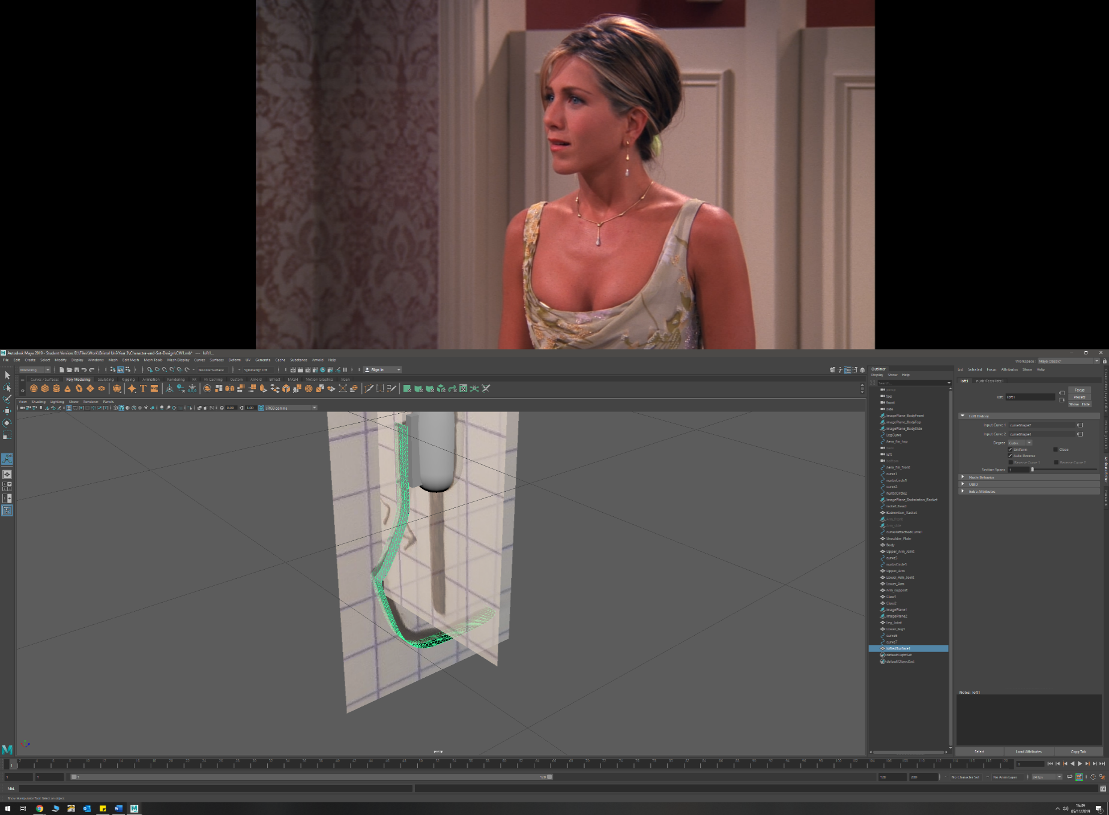

* CV curve
  + Badminton racket head
  + Leg mount
* Tracing from imported images with EP curve (real life and sketches)
  + Badminton racket (real life object)
  + Running blade (Personal sketches)
  + Shoulder pad (personal sketches)
* Lofting between two curves
  + Arm Exoskeleton
  + Running Blade

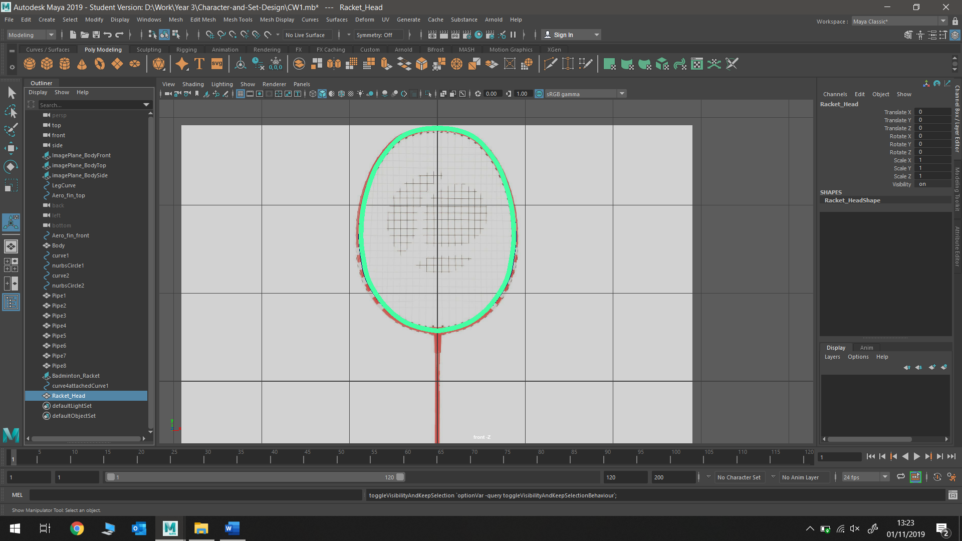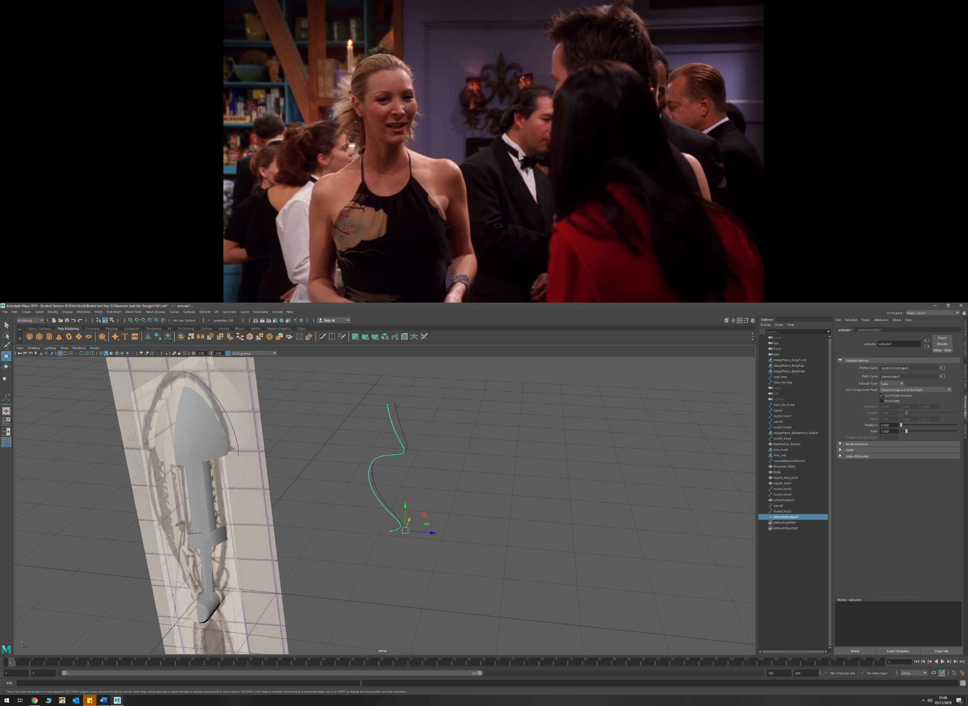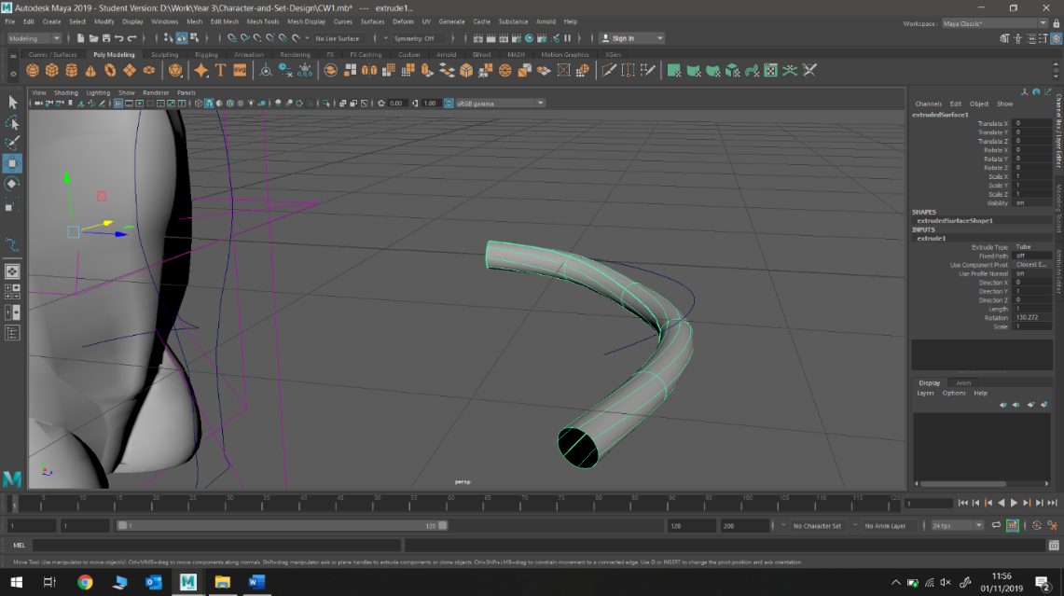

* Target Welding
  + Shoulder mounting plate
  + Torso
  + Forearm
* Extruding a NURBS along a curve (with and without twist)
  + Torso pipe details (with twist)
  + Arm wire detail (no twist)
  + Badminton racket head (no twist)

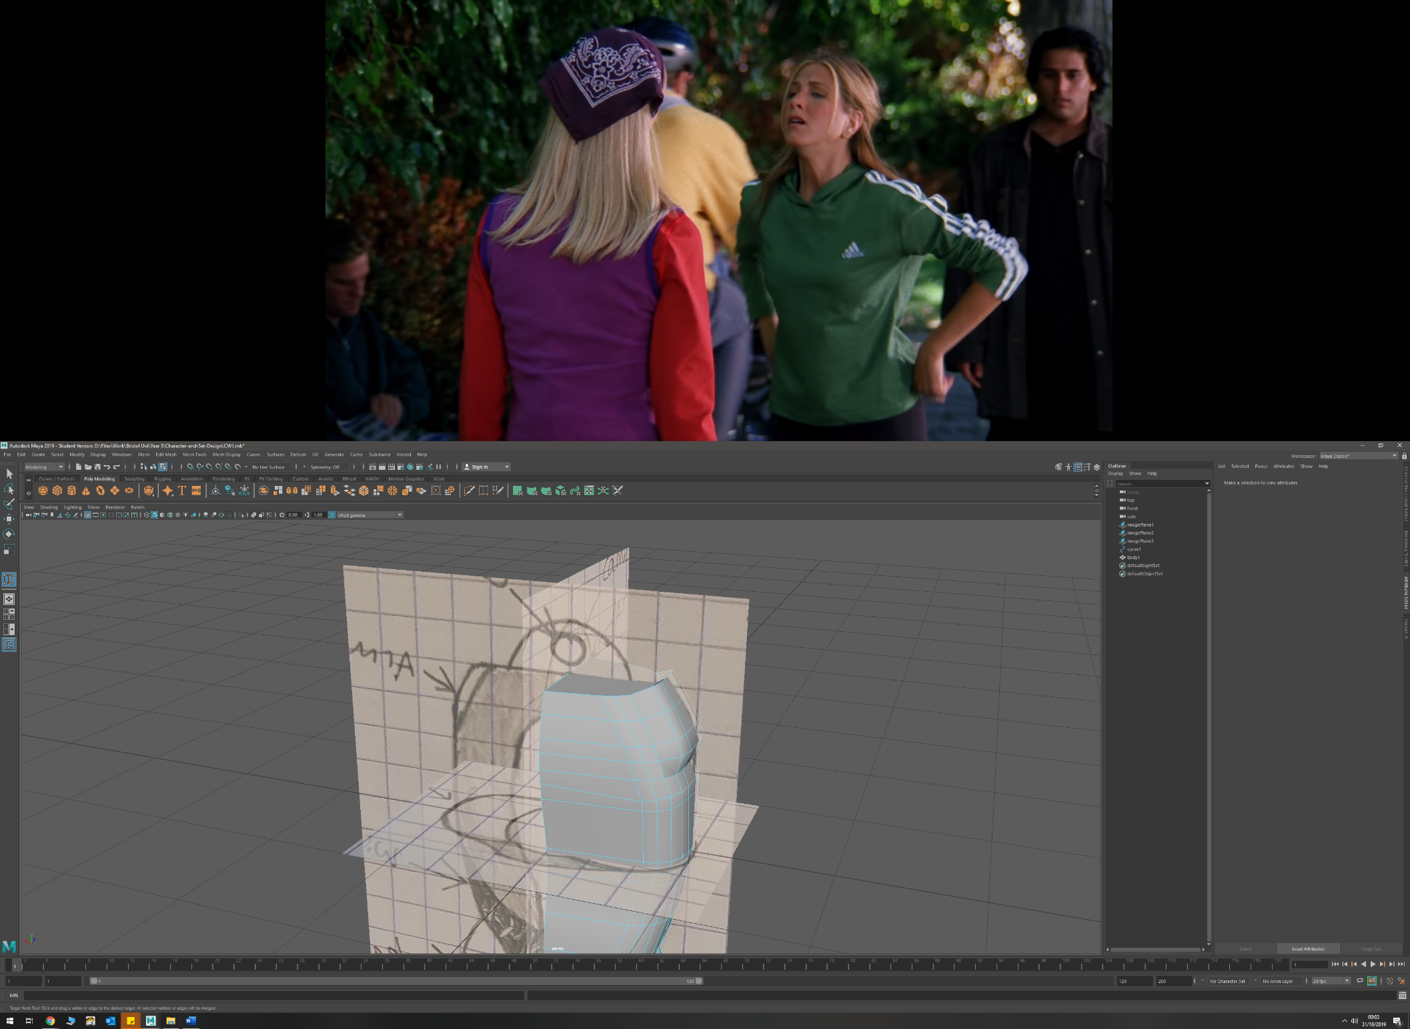

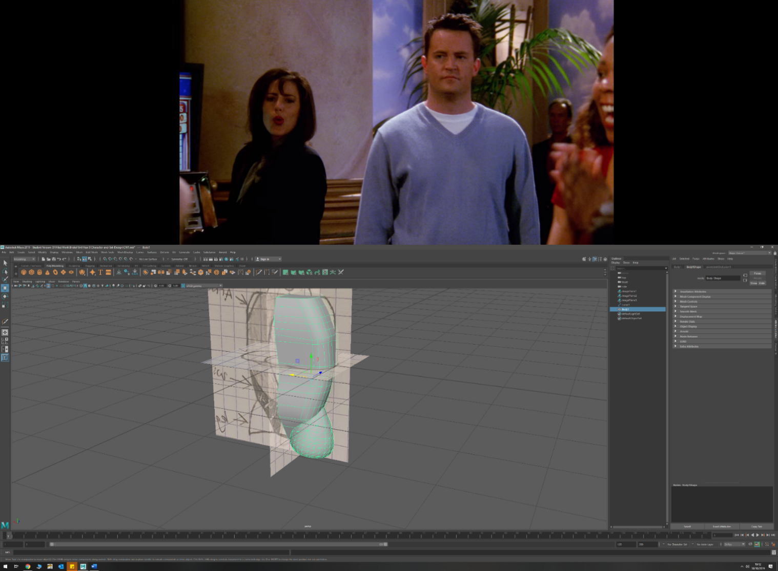

* Bevelling on edges and vertices
  + Torso front and read edges near shoulders
  + Claw end
* Boolean union, difference
  + Racket mesh (both)
  + Arm Exoskeleton mesh (both)
  + Leg mounts and torso (union)
  + Arm – to shape upper and lower arm around joint (difference)
  + Leg – to shape upper and lower leg around joint (difference)

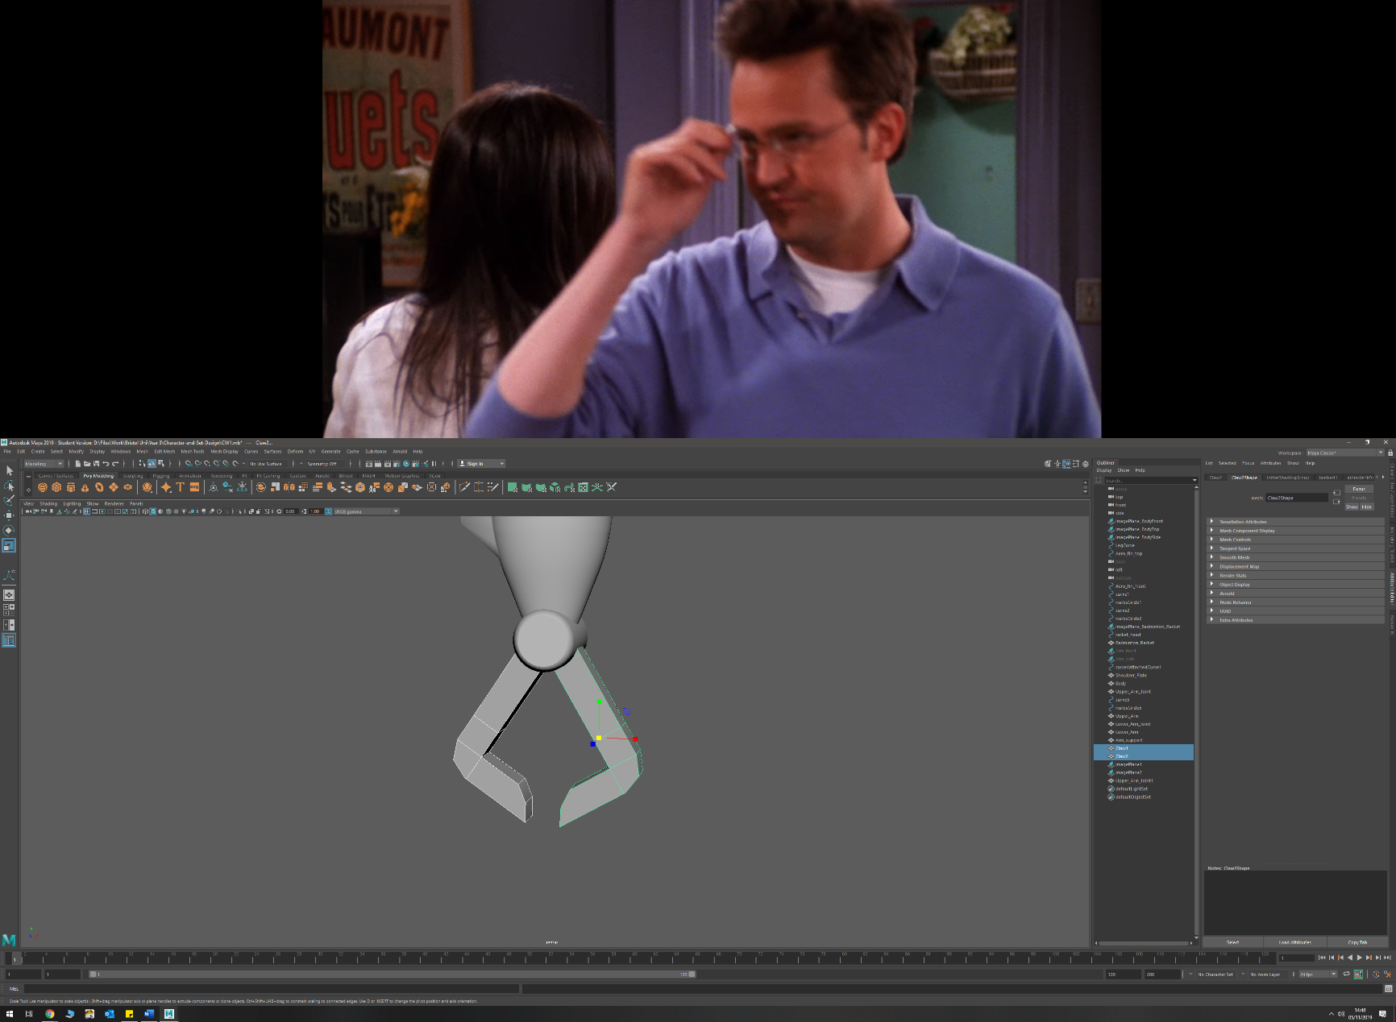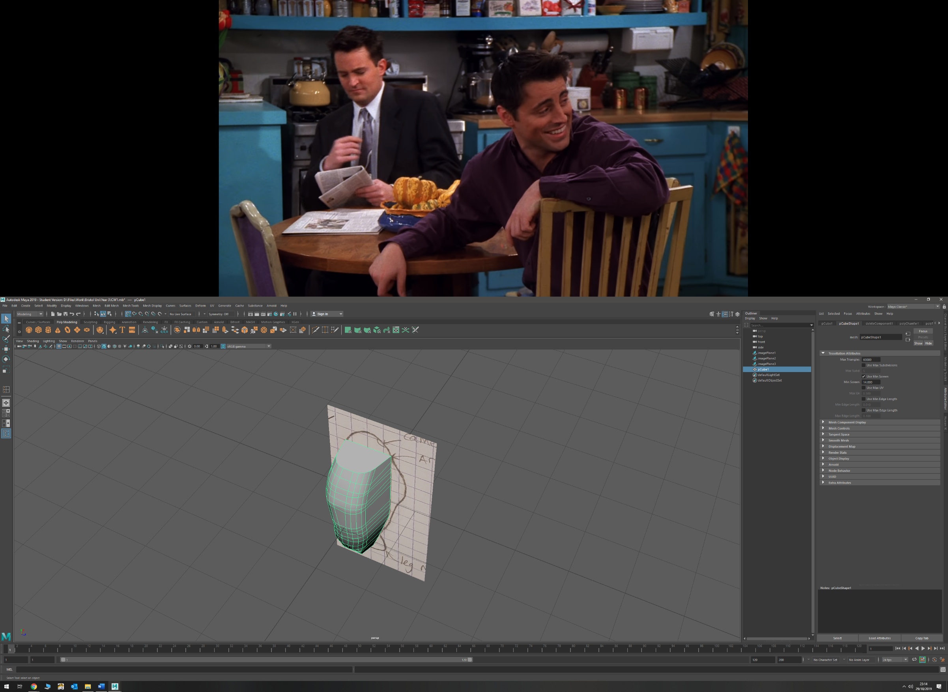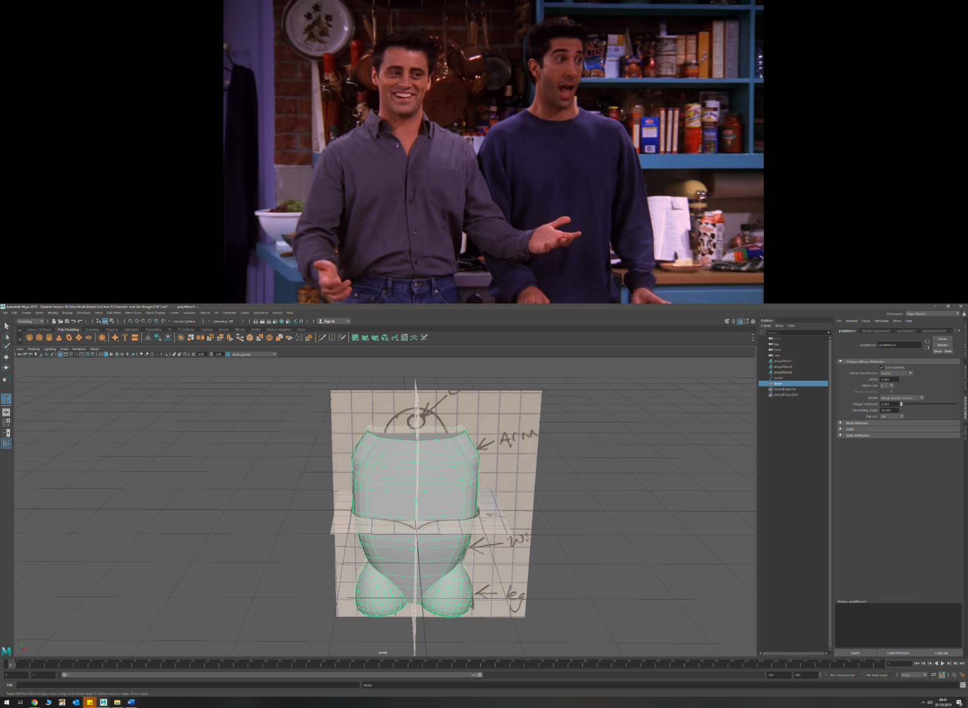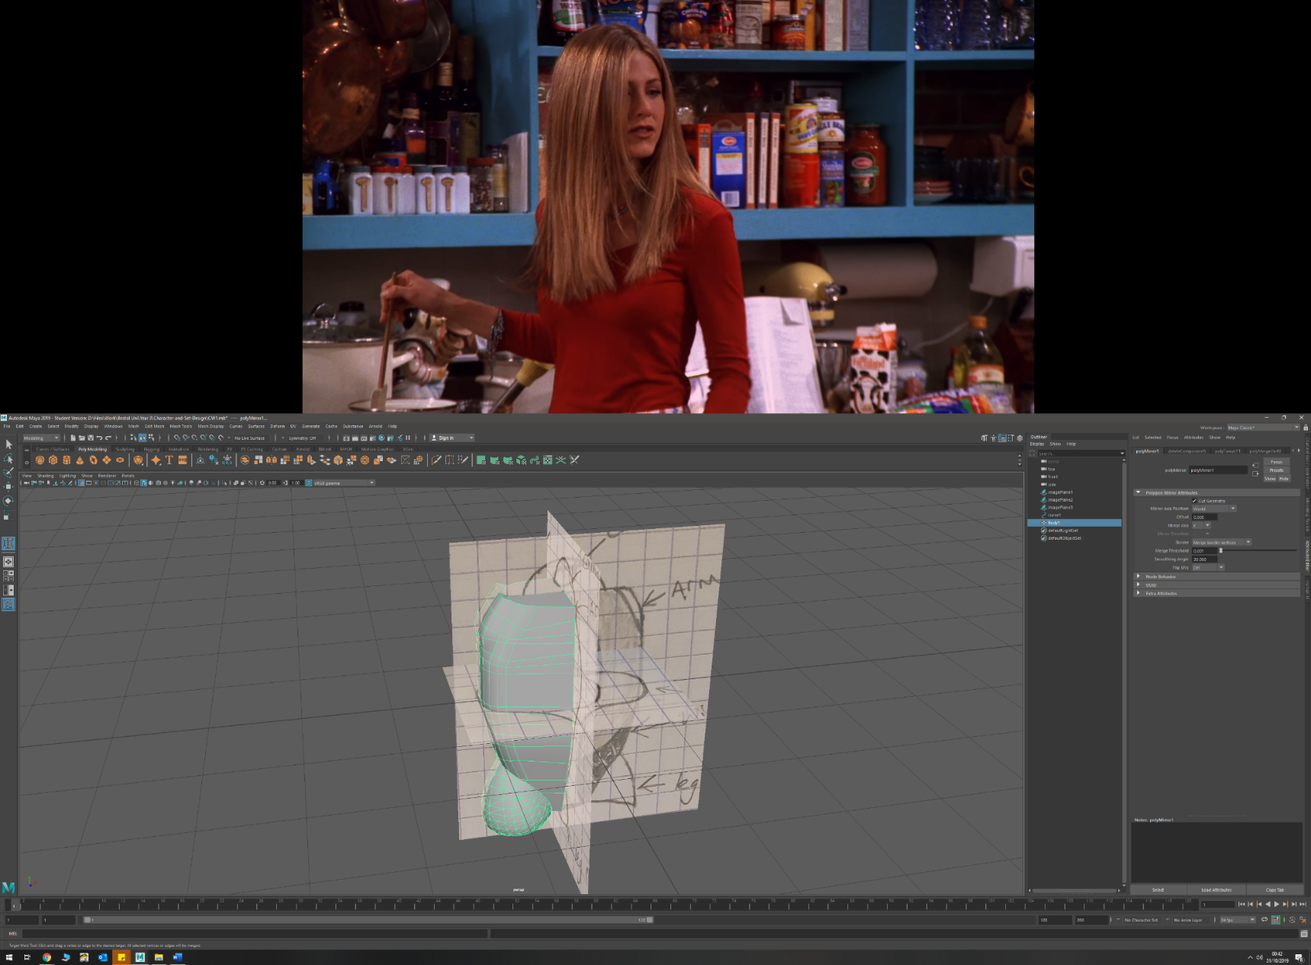

* Mirroring
  + Torso
* Duplication and inverting scale to flip
  + Arm
  + Leg
* Combining Polygons
  + Badminton racket mesh
  + Arm Exoskeleton mesh
* Tessellation (NURBS to polygon)
  + Leg mounts
  + Badminton Racket

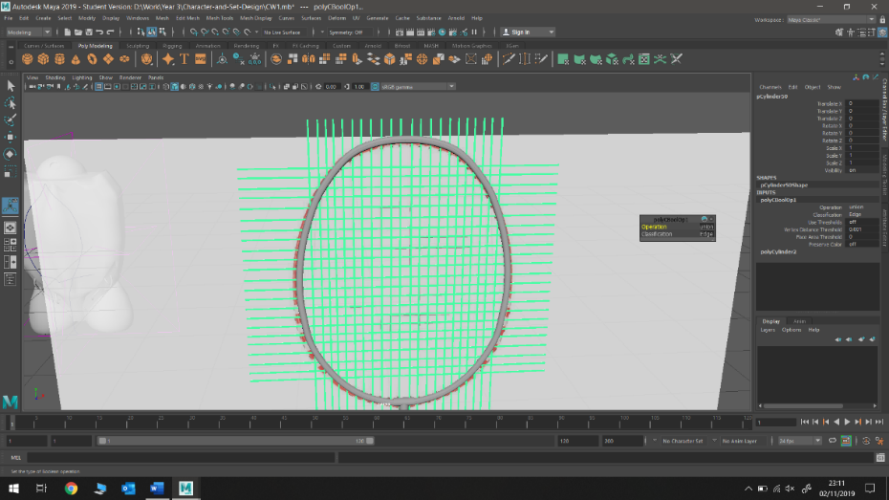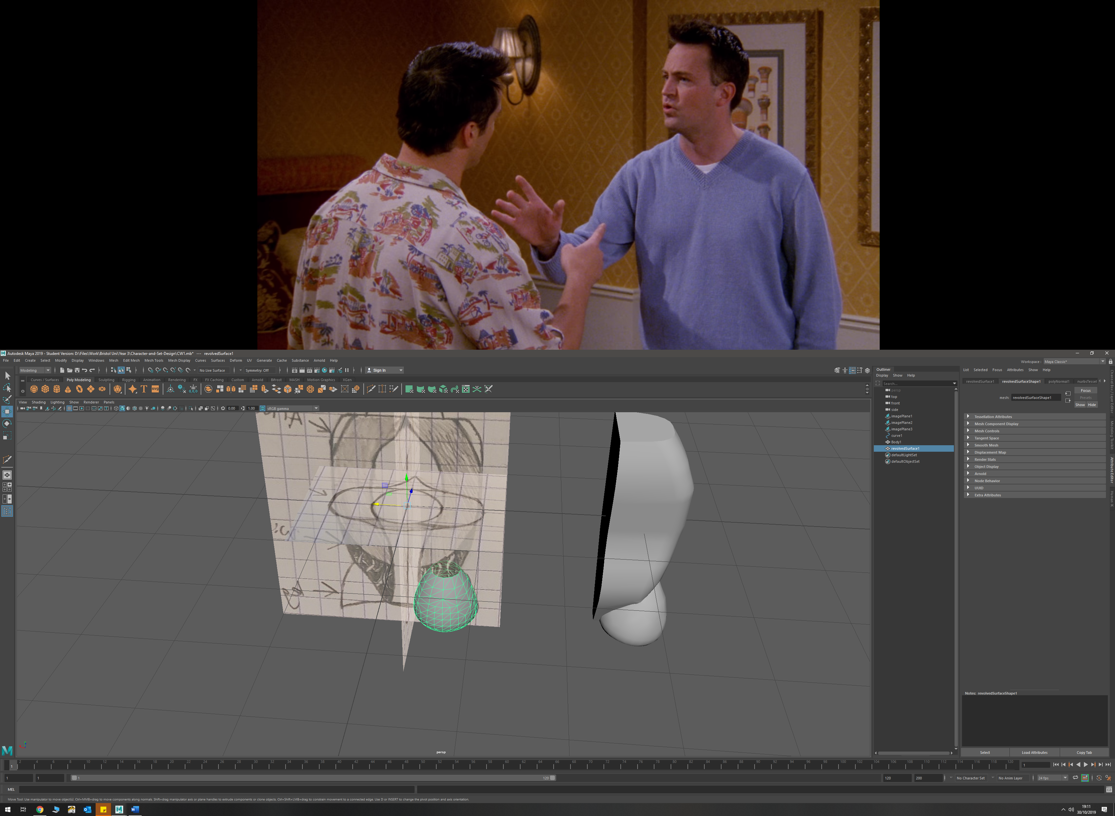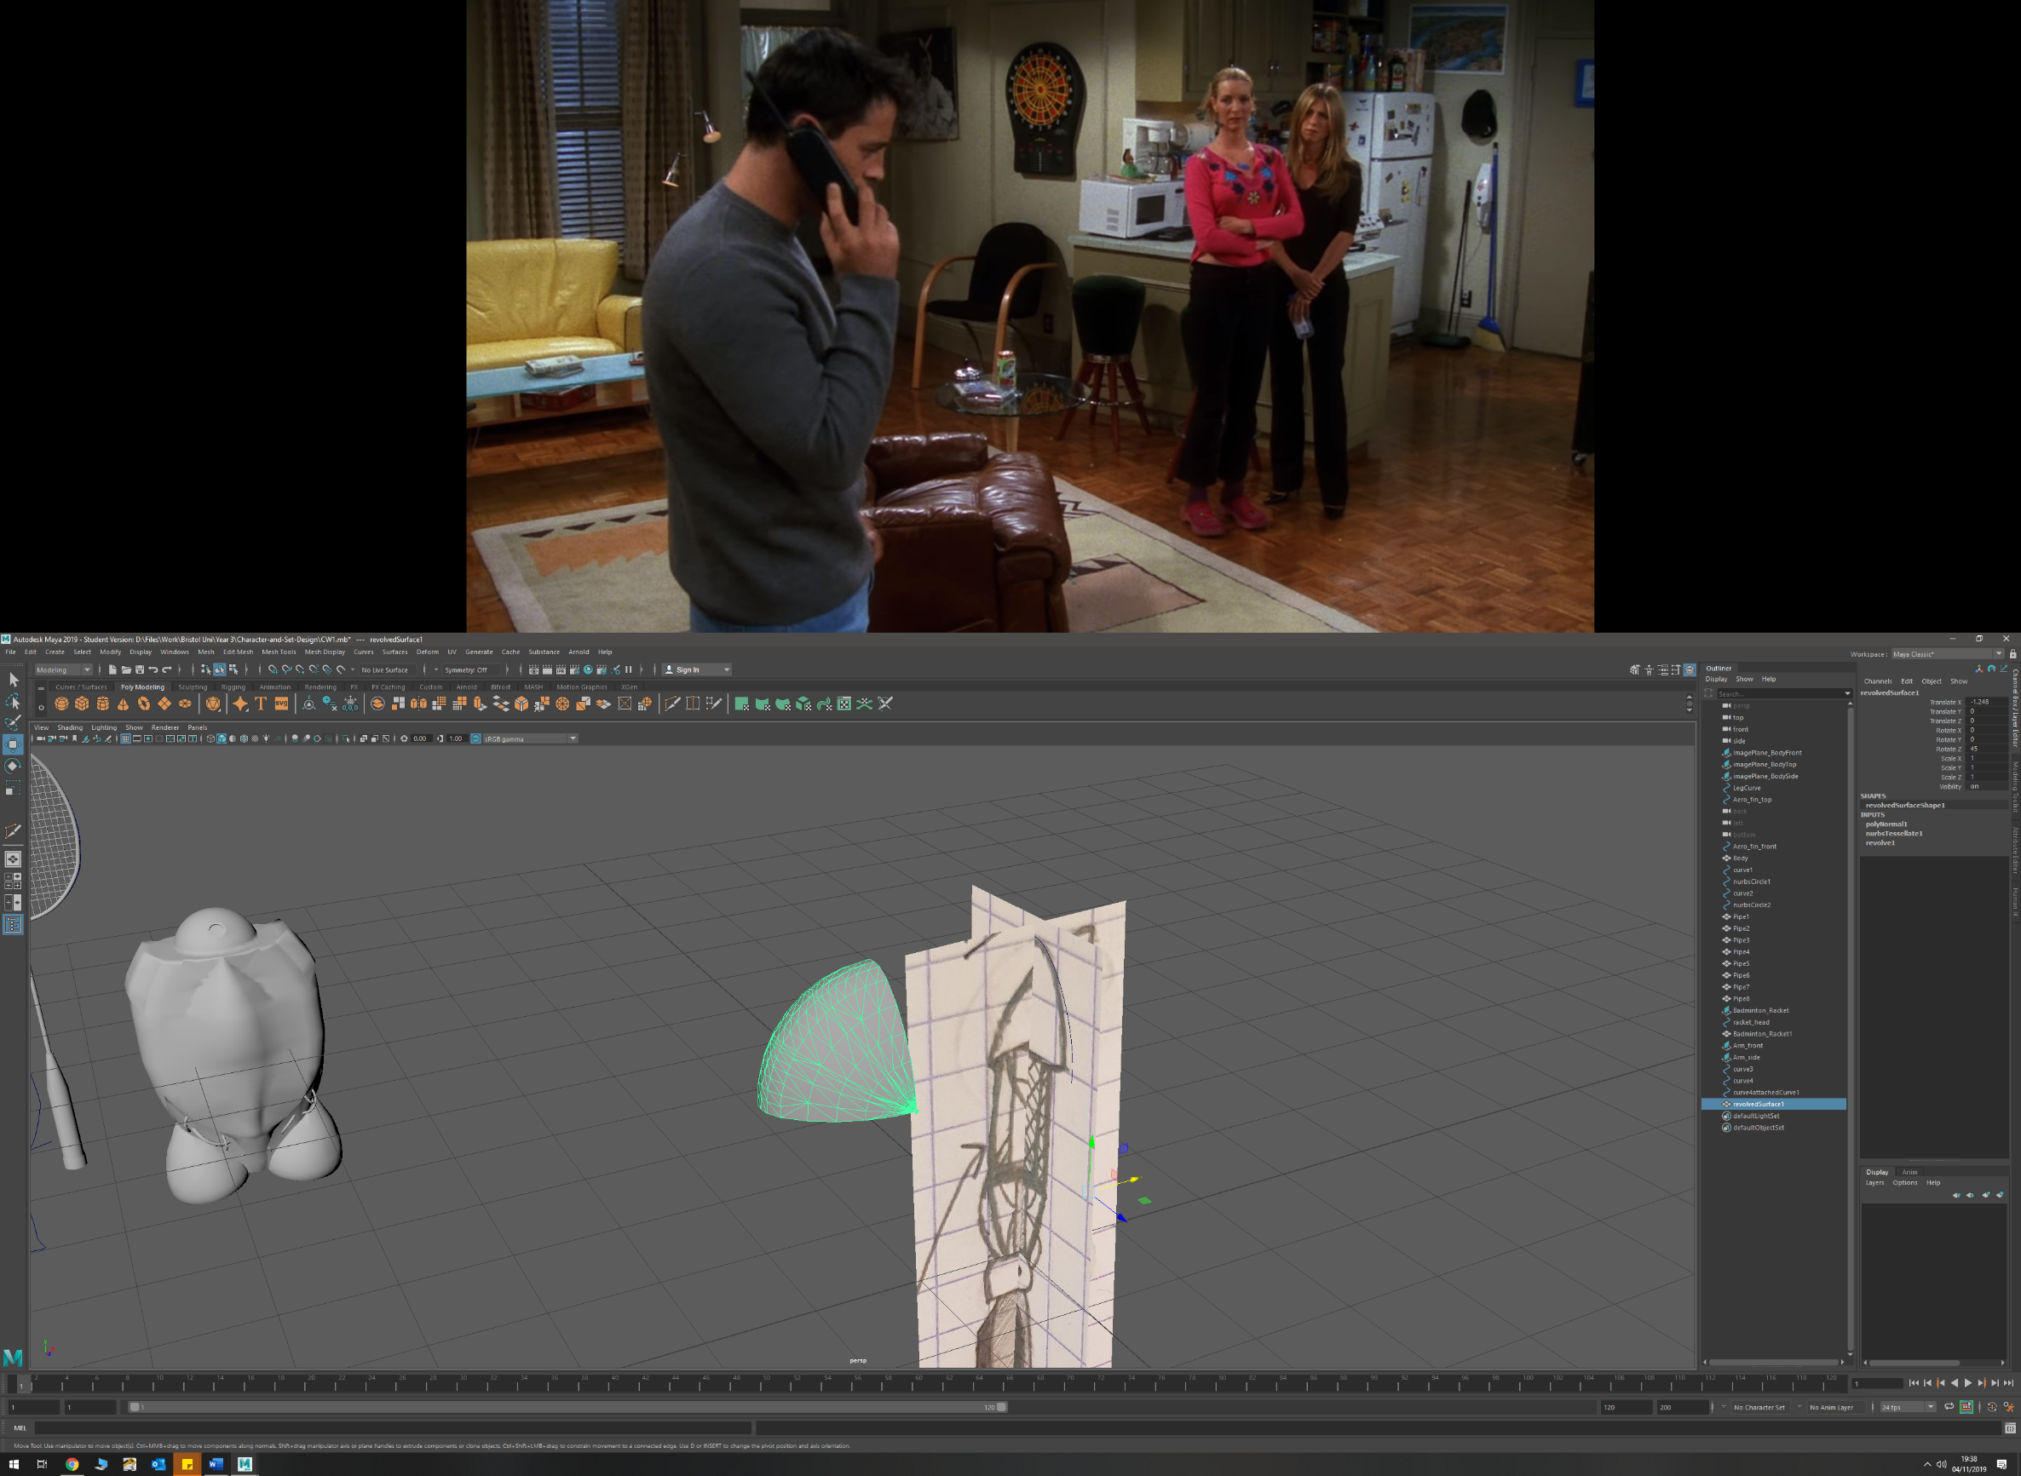

* Mass Duplication
  + Badminton racket mesh
  + Arm Exoskeleton side mesh
* Projection of curve onto surface
  + Aero-fin onto torso
* Revolving a profile curve
  + Leg mounts (360 degree)
  + Shoulder Pads (90 degree)

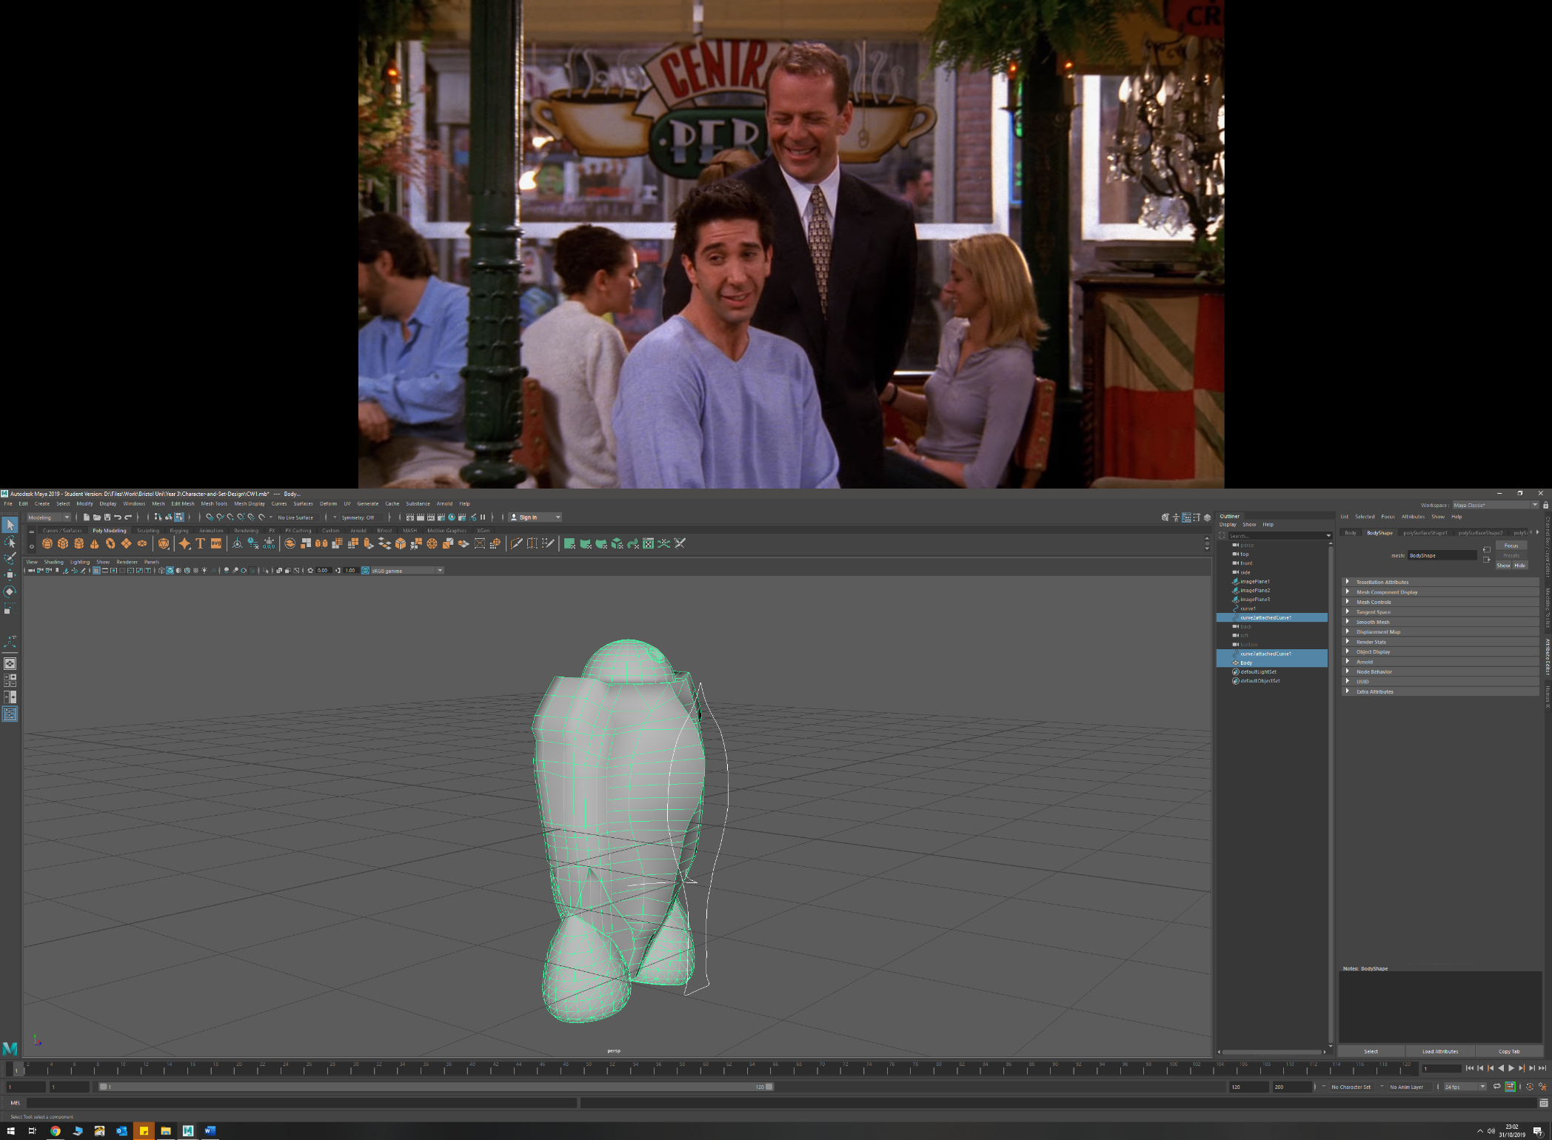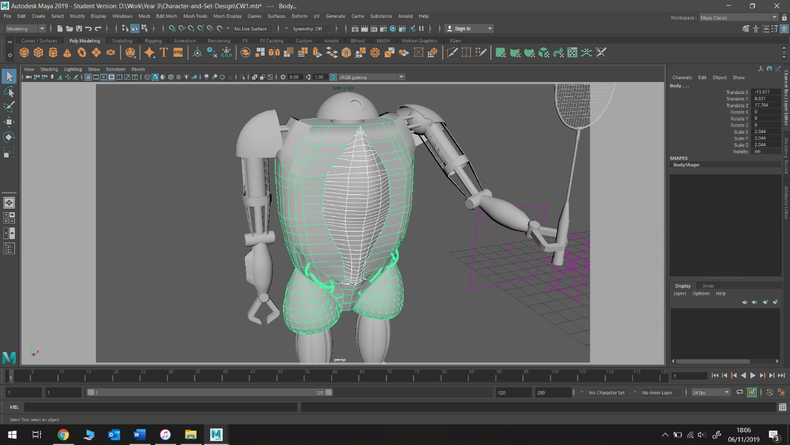

* Separating polygonal faces
  + Aero-fin from torso
  + Shoulder mounts from torso
  + Head from torso
* Smoothing by subdivision
  + Torso back in recessed detail to match curvature more smoothly
* Attaching two curves (create half of curve then duplicate and attach)
  + Badminton racket
  + Shoulder pad

**Process and Discussion**

Initially I started by modelling the robot’s body. I first imported the top, side, and front sketches into Maya so I could use the various orthographic views to model off my designs accurately. The body started off as a cube, which I then scaled lengthways to be the total height of the body. At this point, I changed to the side camera view and added in edge loops at numerous points along the height of the cube. This allowed me to then select the vertices and edges and drag them to match the desired curves I wanted for my robot’s torso.  
This process of moving the edges and vertices was repeated until the body of my robot had matched the dimensions of my blueprints both in size and geometrically.   
To create the taper at the bottom of the torso, I extruded the bottom edge downwards to the desired depth, and then scaled this bottom face to a smaller size in order to create the desired tapering inwards. Again, edge loops were added so that the torso could be formed to the correct dimensions of the blueprints.   
At this stage, I added a new cube, and scaled it up to be 4x4x4. I then positioned it, so its edge was over the origin (and middle of my torso object). Then using a binomial difference, I made a clean face where the middle of the torso would be. This enabled me to perform a mirror later once the torso was complete with leg mounts, so that I did not have to try and duplicate what I was doing on both sides of the model, providing a clean and consistent look to the model.

Primitive up modelling was chosen here for several reasons. Firstly, I wanted my robot to have a sharp geometric look to it, with subtle curves, to give it a rugged and as if it were constructed from metal panels. Using a curve and either revolving or extruding it did not make sense to me as this would have produced too smooth of an object. Additionally, having full control over the edges and vertices allowed me to alter the curvature of the back very easily, as well as quickly being able to create the desired taper towards the bottom, allowed me to customise the look of the torso as I went. Furthermore, it was useful for later stages of modelling to have large, flat surfaces to extrude off, and to be able to easily modify the torso shape when desired.

To create the desired roundness of the torso, creating a flow from the front round to the back, the edge was bevelled using the bevel tool. In the bevel tool settings, the number of bevels was increased to 4 in order to create a smoother transition. Using this tool proves very quick to use and gave me the desired effect with little effort or complexity, while also keeping the edge flow consistent and clean.  
the bevel tool was also used on the bottom edge of the torso to give the desired effect. Again, the bevel tool was chosen for its simplicity and ease of use.

The shoulder mount was created by extruding faces towards the upper edge of the torso outwards, and then using the target weld tool on the surrounding edges to create clean curves easily. I did experiment by using the bevel tool to create the smooth edge, but this caused the shoulder mount to lose a lot of its size and did not create the desired look. The weld tool however provided clean geometry, did the job quickly, and allowed for more control over the sharpness of the corner. The top edge was left un-welded to add sharpness to the upper body of the robot. Additionally, it gave the shoulder mount a more pronounced look, which I preferred over what I had planned with my sketches.  
After doing an ambient occlusion of the model, the shoulder mounts were not as pronounced as I would have liked. To combat this, I separated the shoulder mounts faces from the main body object, making for a sharper interaction between the two objects. Doing this provided me with the crispness I wanted from the model.

Constructing the leg mounts was achieved my using the CV curve tool to trace over my sketch. A CV curve was selected so that I could create the rounded point on the lower part of the curve, which would create the desired lip once rotated. After rotating I ended up with an object that has a radius which was too big. To combat this, I changed the point about which the rotation was performed in the revolve tool’s settings. Whilst this gave me the desired shape and radius after some trial and error, it did not provide clean edge flow, and had many overlapping edges and faces. I cleaned up this topology by deleting all the overlapping faces, and then using the fill hole tool to fill the resulting hole. This was a quick and easy way of correcting the edge flow and removed a pole from the geometry. The leg mount was then positioned in the desired location, overlapping with the body somewhat, and converted from a NURBS to a polygon using tessellation. The body and leg mount where then joined using a Boolean union. This eliminated any non-manifold geometry that would have been caused by using a combine operation, whilst also allowing for easy modification to the leg mount’s position without disrupting the edge flow (before the history was deleted).

Towards the bottom third of the torso, I had planned to have visible piping and wires on the front, and a vent system on the back. To illustrate this detail in a more pronounced way, I used the Multi-cut tool in order to alter the geometry of the torso in such a way to get the desired curve of the indentation. Once this was completed, I extruded the faces under the constructed edge curve inwards to create the desired depth.  
On the rear of the model, I decided to add the venting detail when texturing and shading, as the desired detail could have created poles and poor edge flow due to the scale and size of the desired mesh. However, if I had decided to make the mesh detail using polygons, I could have used a mesh of overlapping cylinders, and then use the bend tool in Maya to curve this mesh to the correct curvature of the torso section.

For the front section of the torso indentation, I decided to add some pipe detains using geometry rather than in the texturing stage. This decision was made as the depth of overlapping pipes extruding from the torso would add realism and good detail to the model, whilst also not effecting the edge flow too badly.   
These pipes were constructed by drawing a curving EP curve, and then using the extrude tool with a scaled down NURBS circle prefab to create the pipe shape. To give a more chaotic but natural appearance to the pipe, I chose to twist the pipe by 270 degrees in the extrude tool settings. I then duplicated the resulting pipe, scaled some of these, and utilised the different sections to create a variety of overlapping pipes for both sides of the torso. Alternatively, I could have drawn more EP curves to create the pipe variation, but the method of duplication was much quicker, and still provided the end model with some degree of variety.  
To clean the overlapping topology of the pipes and the torso, a Boolean union was once again used to create a clean edge flow.

The BB-8 inspired head was created by simply halving a sphere polygon prefab, and then shaping it to the correct size. This method proved quick and simple and gave me my desired look. Initially, the head was attached directly to the top of the torso via a union Boolean. However, this provided me with some off geometry and rendering effects when the ambient occlusion was performed. This was combated by removing the bottom row of faces from the head sphere, filling the hole in the bottom, scaling this face inwards, then extruding this smaller face. Whilst this successfully combated the rendering issue, it also gave my model a more realistic appearance as it is clearer how the head can rotate separate to the torso.

To create the camera on the head, I used the circularise tool in Maya twice, to create an inner and outer band. I then extruded the inner circle inwards, and the band outwards to create the camera in a simple way. This shame effect could have been achieved by using a poke, or a Boolean with a cylinder, but the circularisation approach gave me more flexibility in camera size, and ultimately a higher quality of detail with much less effort.

**Body**

* Added edge loops to a cube after manipulating size to match sketches
* Manipulated new edges in order to fit body to match blueprints by moving positions in the different orthographic views
* Bevelled edges using bevel tool to get correct shape. Changed number of bevels to 4
* Bevelled 2 vertices near bottom of model in order to make shape more coherent
* Drew curve around leg mount to get shape
* Used revolve tool in order to create a polygon cone of the correct shape, and used reverse so polygonal mesh was the correct way around
* Extruded edges on top of cone to make correct shape, and a binomial in order to merge the leg mount and body
* To make shoulder plates, extruded faces, then merged edges using target weld tool to create smooth transition
* To create the full body, I used the mirror tool and rotated until as full mesh was created
* Body detail was added by selecting faces and extruding them inwards. This will allow me to add inner wiring and cooling vent details once rendered.

* Created the aerodynamic fin by adding edges to the front of the torso, then selecting faces and extruding them. I then drew a curve to match my sketches of how I wanted the fin to look like from the front, and the side. I then moved vertices to match these curve shapes and create the fin. I also used the target weld tool in order to create the angles I wanted in different sections.
* Used the circularise tool twice, with increased divisions in order to create the camera on the head/dome. I then extruded the outer loop outwards, and the inner circle inwards to create the depth I required

* To create pipe detains on torso, I used a NURBS prefab circle, and drew a EP curve, then extruded a tube by selecting the two. I changed the extrude settings in order to get a rotation in the tube.

This process was repeated several times to get different tube shapes, thicknesses and paths

**Badminton Racket**

* Badminton racket head was made by tracing round an image of the racket with an EP curve, then extruding a NURBS circle along this path. The polygon was then duplicated, and a Boolean was used to join the two halves together.
* The rest of the racket was constructed using polygon cylinders that I manipulated to fit the correct shaped of the racket handle; extruding faces and altering face size

* Badminton racket mesh was created by duplicating a polygon cylinder multiple times to fit frame

Used a duplicated racket hoop (made larger) to apply Boolean to mesh in order to cut off points of mesh not inside hoop

Used separate in order to separate the wanted and unwanted sections of the mesh, and then simply deleted the unwanted (outside the hoop) part of the mesh

**Arm**

* To make shoulder plate, I drew around half my sketch, and duplicate this to get a perfectly symmetrical curve

I then did a 90 degree revolve about z to get the correct shape

After this I tidied up the lower geometry by deleting faces

* Created connecting stems by using the circularising tool on 4 faces, then extruding these new circular faces outward
* Created upper arm using cylinders and then manipulated and extruded certain faces to get the desired shape
* Upper arm casing made by using 2 NURBS prefab circles with 8 linear sections in order to give it a octagonal style shape. Then duplicated this NURBS and used a loft between the two

I then extruded the octagonal lofted ring in order to give it depth

* Next I extruded up select faces of the octogen in order to create the connecting beams with the shoulder joint
* For wire detail, I created an overlapping, flat EP curve and then manipulated the curves points to make it into a spiral shape. I made this fit around the inner arm. I then used a NURBS circle and extrude to create a thin pipe/wire
* The Forearm was created with a cylinder and was shaped by extruding faces and reducing face sizes. The whole object was then smoothed to match the sketch design

Forearm detail was made by moving edges on the forearm

* To create the claw, I used poly extrudes, and added edge loops to create the general shape. I then bevelled the claw tip to create the correct shape

**Leg**

* Lower leg made up of circle that was chopped in half, and then extruded upwards
* Performed a union Boolean to attach the back-leg mount
* Traced around the sketch with and EP curve to create the outline for the blade, then duplicated this curve. Did a loft between the curves, then extruded this new polygon to get depth
* Added blade screw detail by circularising faces, and then extruding slightly
* Upper leg and hip joint was created using polygon prefabs, and then manipulating faces and edges by scaling their size and extruding them where necessary

**Appendix**

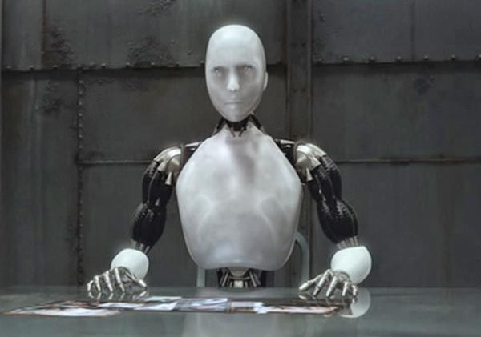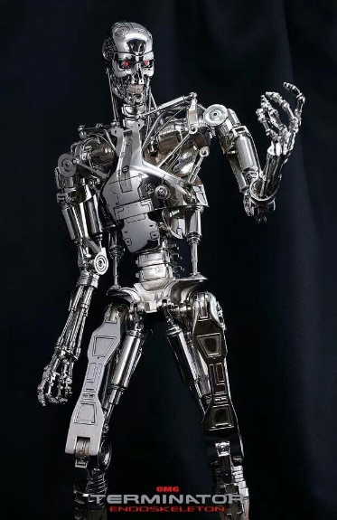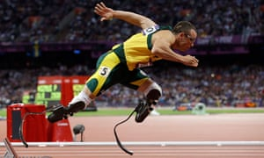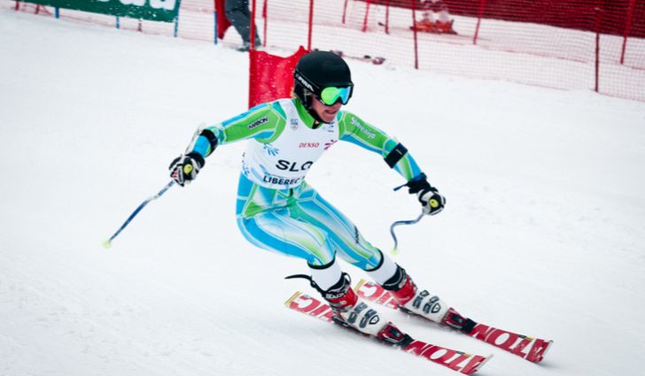**Style Sheet and Visual References**

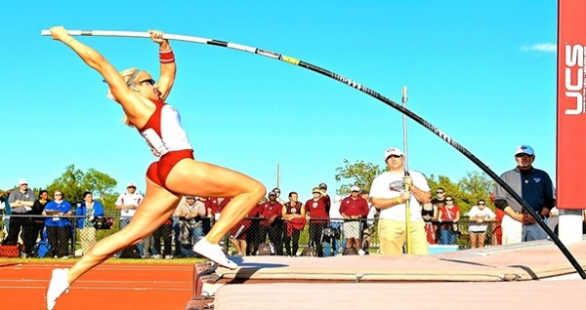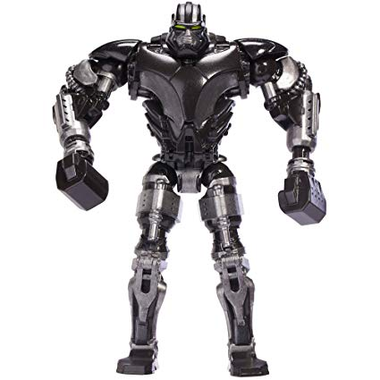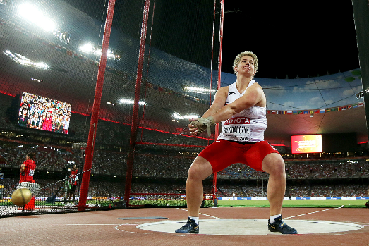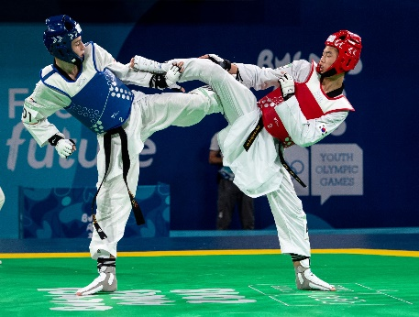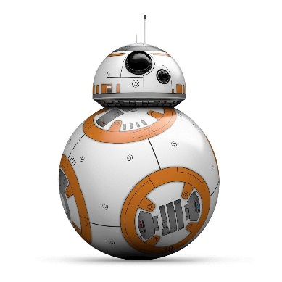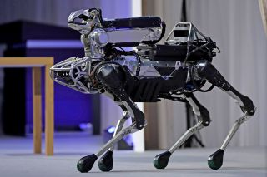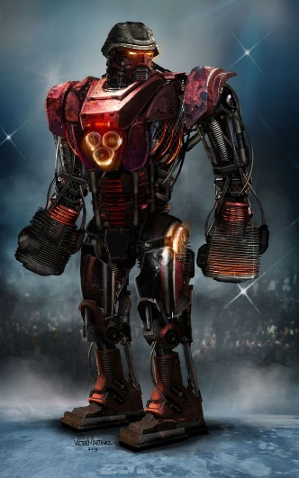

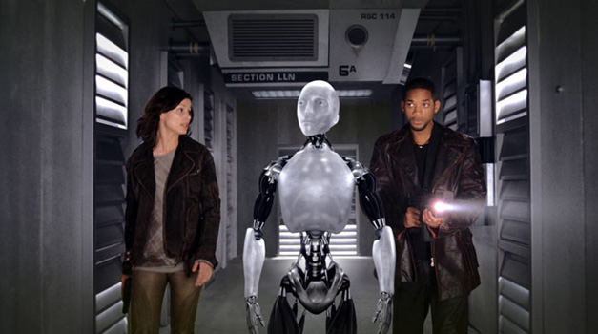

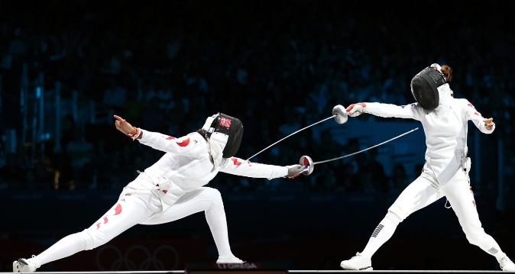

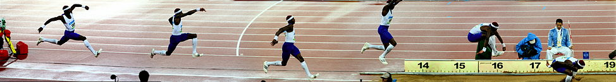

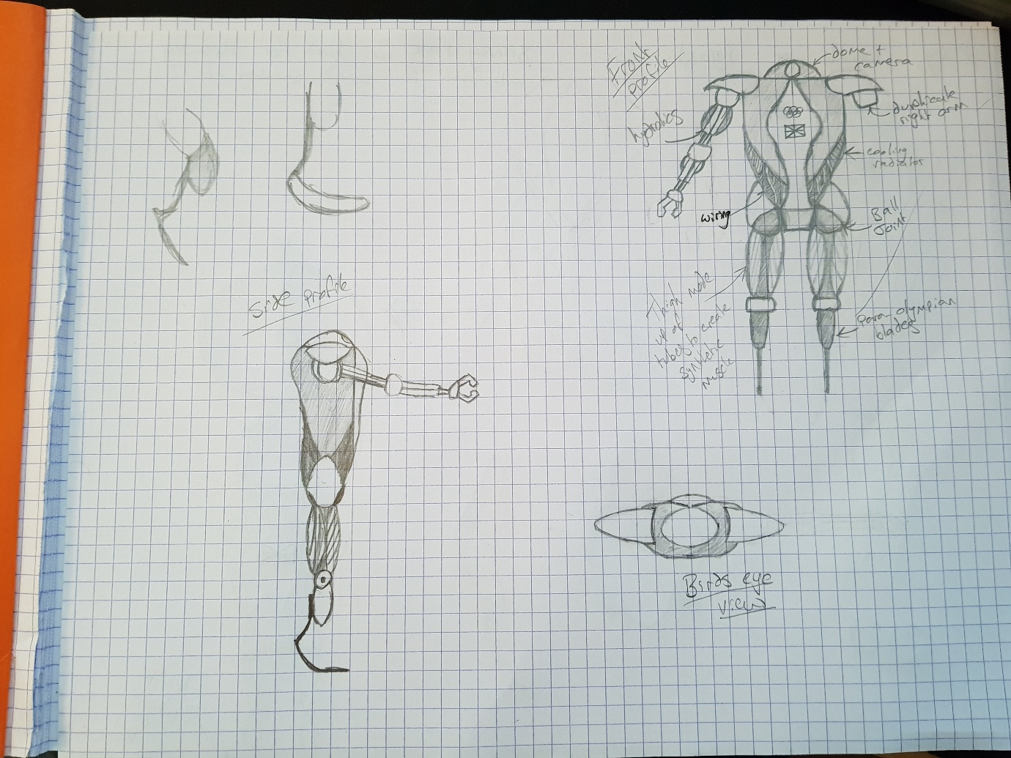**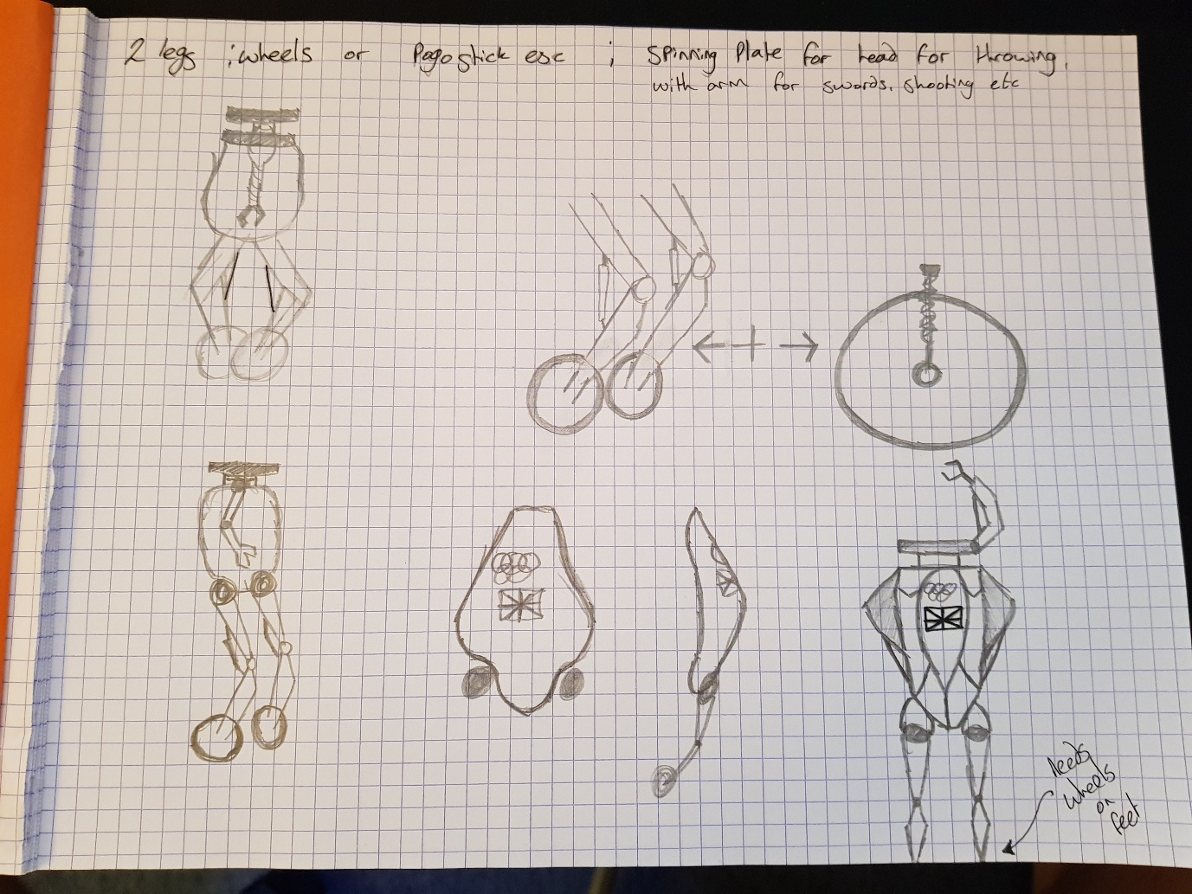Development Drawings**

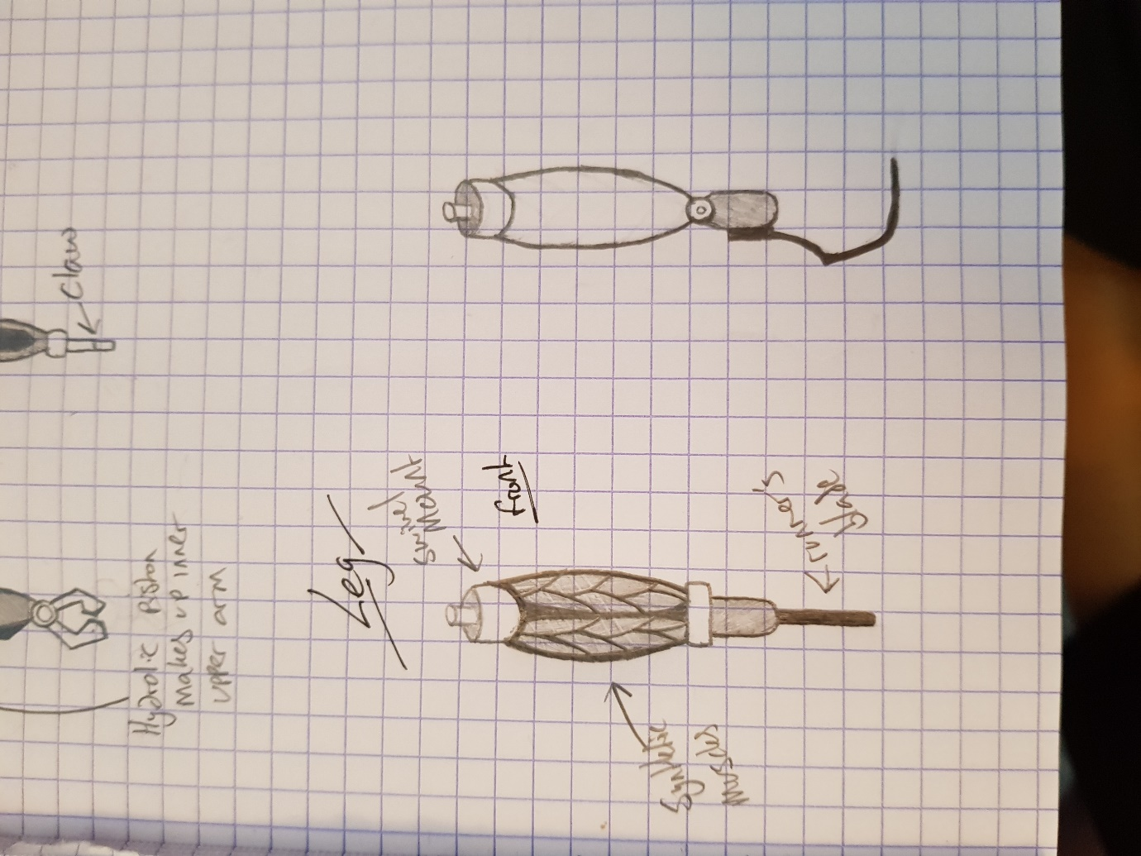**Sketches and Blueprints**

